Name

Mathematics Stage 4
Area of Parallelograms and Triangles

Book 1 |  | Version: 260707  Feedback:  https://MrDingMaths.com
Contents
Syllabus Content 2
Converting Units of Area 4
Area of Squares and Rectangles 14
Area of Parallelograms 22
Area of Triangles 28
Mixed Practice 34
Area of Composite Figures 36
Finding Unknown Sides Given the Area 44

Syllabus Content
MA4-ARE-C-01 applies knowledge of area and composite area involving triangles, quadrilaterals and circles to solve problems
Choose appropriate units of measurement for area and convert between units
- Choose appropriate units of measurement for area and convert between units
- Choose an appropriate unit to measure the area of different shapes and surfaces, and justify the choice
- Convert between metric units of area using 1 cm² = 100 mm², 1 m² = 10 0000 cm²,
1 ha = 10 000 m², and 1 km² = 1 000 000 m² = 100 ha
Develop and use formulas to find the area of rectangles, triangles and parallelograms to solve problems
- Apply the formula to find the area of a rectangle or square: $A=lb$, where $l$ is the length and $b$ is the breadth (or width) of the rectangle or square
- Develop and apply the formula to find the area of a triangle: $A=$ $\frac{1}{2}bh$, where $b$ is the base length and ℎ is the perpendicular height
- Develop and apply the formula to find the area of a parallelogram: $A=bh$ where $b$ is the base length and ℎ is the perpendicular height
- Calculate the area of composite figures that can be dissected into rectangles, squares, parallelograms or triangles to solve problems

Converting Units of Area

- Review
- Convert units of length.
- 5 cm to mm | - 3 m to cm | - 2 km to m | - 400 mm to cm

- Calculate area of a square.
- 10 mm | - 1 cm | - 100 cm | 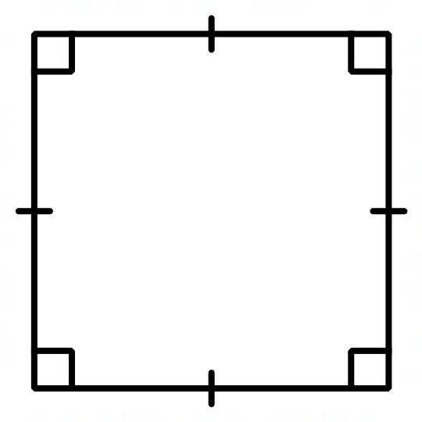  - 1 m
- Multiply and divide by powers of 100
- $40×{10}^{2}$ | - $7×{100}^{2}$ | - $60 000÷{10}^{2}$ | - $5000÷{100}^{2}$

- Units of Area
Area is the amount of space taken up by a flat object.
Area measured in square units.
1 square millimetre,  1 mm² | 1 square centimetre,  1 cm²
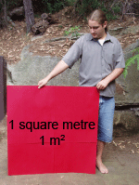  1 square metre  1 m² | 1 square kilometre  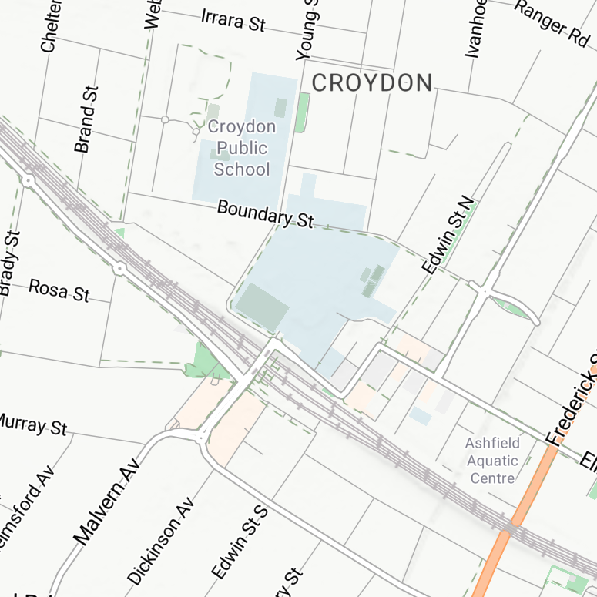  1 km²
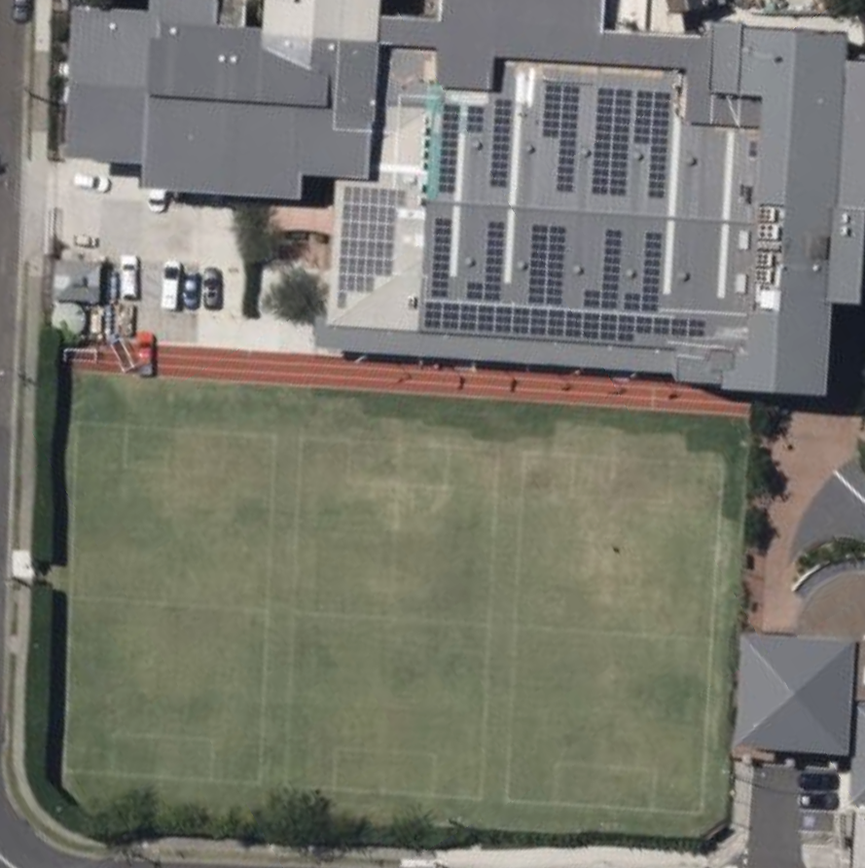
1 hectare is area of square with each side 100 m.
1 ha

- Identify Most appropriate unit of area
Circle which unit(s) of measurement would be most appropriate to measure these areas.
My desk: | $$mm^{2}$$ | $$cm^{2}$$ | $$m^{2}$$ | $$ha$$ | $$km^{2}$$
My page: | $$mm^{2}$$ | $$cm^{2}$$ | $$m^{2}$$ | $$ha$$ | $$km^{2}$$
An insect: | $$mm^{2}$$ | $$cm^{2}$$ | $$m^{2}$$ | $$ha$$ | $$km^{2}$$
My phone: | $$mm^{2}$$ | $$cm^{2}$$ | $$m^{2}$$ | $$ha$$ | $$km^{2}$$
A farm: | $$mm^{2}$$ | $$cm^{2}$$ | $$m^{2}$$ | $$ha$$ | $$km^{2}$$
A basketball court: | $$mm^{2}$$ | $$cm^{2}$$ | $$m^{2}$$ | $$ha$$ | $$km^{2}$$
Size of Sydney: | $$mm^{2}$$ | $$cm^{2}$$ | $$m^{2}$$ | $$ha$$ | $$km^{2}$$
An ant’s head: | $$mm^{2}$$ | $$cm^{2}$$ | $$m^{2}$$ | $$ha$$ | $$km^{2}$$
Size of Australia: | $$mm^{2}$$ | $$cm^{2}$$ | $$m^{2}$$ | $$ha$$ | $$km^{2}$$
A soccer field: | $$mm^{2}$$ | $$cm^{2}$$ | $$m^{2}$$ | $$ha$$ | $$km^{2}$$
The room: | $$mm^{2}$$ | $$cm^{2}$$ | $$m^{2}$$ | $$ha$$ | $$km^{2}$$

- Investigation Area conversions
The square on the left has area 1 mm² and the square on the right has area 1 cm²

Describe what a square mm is ………………………………………………………………………
Describe what a square cm is ………………………………………………………………………
How many squares of 1 mm² can fit in a square of 1 cm²?
………………………………………

How many mm in a cm? ………………………………………………………………………
How many mm² in a cm²? ………………………………………………………………………
How many m² in a km²?
1 km

1 km

- Converting Units of Area
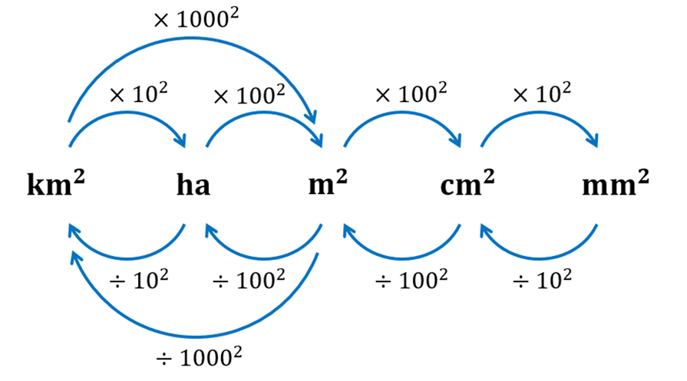

- Example Convert units of area
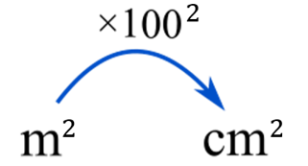  20 m² to cm²  $20 m^{2}×{100}^{2}$  $=200 000$cm² | 1500 mm² to cm²  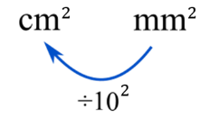  $1500 {mm}^{2}÷{10}^{2}$  $=15 {cm}^{2}$

- Guided Practice
Convert these units of area
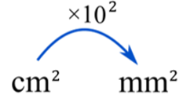  - 5 cm² to mm²  500 mm² | - 2 m² to cm²  20000 cm² | 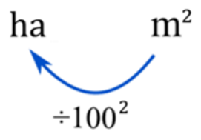  - 35 000 m² to ha  3.5 ha
- 2.1 m² to mm²  2 100 000 mm² | - 400 cm² to m²  0.04 m² | - 0.53 ha to m²  5300 m²

- Key Ideas
- Area is measured using …………… units. 5 m² means the area covered by 5 squares that have sides ……………
- To convert between metres and centimetres, the conversion factor is ……
- To convert between square metres and square centimetres, the conversion factor is ……

Foundation
- Decide whether to multiply or divide, and by what factor.
- Convert cm² to mm²  Multiply ×10² | - Convert km² to ha  Multiply ×10²
- Convert cm² to m²  Divide ÷100² | - Convert km² to m²  Multiply ×1 000²
- Convert m² to ha  Divide ÷100² | - Convert m² to cm²  Multiply ×100²

- Convert to cm².
- Convert 1 m² to cm²  10 000 cm² | - Convert 0.5 m² to cm²  5 000 cm²
- Convert 2 m² to cm²  20 000 cm² | - Convert 0.05 m² to cm²  500 cm²
- Convert 5 m² to cm²  50 000 cm² | - Convert 3.7 m² to cm²  37 000 cm²

- Convert to m².
- Convert 10 000 cm² to m²  1 m² | - Convert 300 cm² to m²  0.03 m²
- Convert 30 000 cm² to m²  3 m² | - Convert 350 cm² to m²  0.035 m²
- Convert 3 000 cm² to m²  0.3 m² | - Convert 74 500 cm² to m²  7.45 m²

- Convert these units.
- Convert 1 ha to m²  10 000 m² | - Convert 20 000 m² to ha  2 ha
- Convert 3 ha to m²  30 000 m² | - Convert 85 000 m² to ha  8.5 ha
- Convert 0.5 ha to m²  5 000 m² | - Convert 500 m² to ha  0.05 ha

- Convert these units.
- 4 m² to cm²  40 000 cm² | - 400 mm² to cm²  4 cm²
- 40 000 cm² to m²  4 m² | - 4 ha to m²  40 000 m²
- 4 cm² to mm²  400 mm² | - 40 000 m² to ha  4 ha

- Express these areas in cm²
30 000 cm² | 5000 cm² | 160 000 cm² | 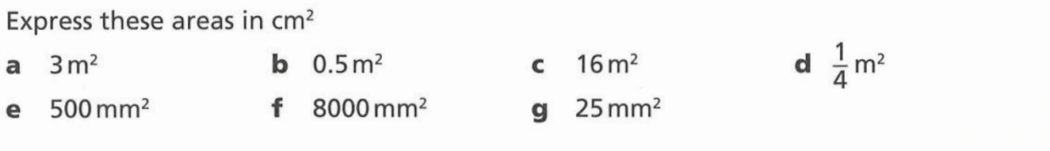  2500 cm²
5 cm² | 80 cm² | 0.25 cm²

- Convert these units. You may need to convert twice.
- 3 m² to mm²  3 000 000 mm² | - 2 km² to m²  2 000 000 m²
- 0.5 m² to mm²  500 000 mm² | - 2 km² to ha  200 ha
- 1 000 000 mm² to m²  1 m² | - 2 000 000 m² to km²  2 km²

- Convert these units of area.
- $90 000 cm^{2} to m^{2}$  9 m² | - $9 m^{2} to cm^{2}$  90 000 cm² | - $0.04 m^{2} to mm^{2}$  40 000 mm²
- $900 cm^{2} to{ m}^{2}$  0.09 m² | - $9 {cm}^{2} to m^{2}$  0.0009 m² | - $36 km^{2} to{ m}^{2}$  36 000 000 m²
- $90 000 mm^{2} to{ m}^{2}$  0.09 m² | - $0.9 m^{2 }to cm^{2}$  9000 cm² | - $3.6 km^{2} to{ m}^{2}$  3 600 000 m²
- $90 m^{2} to cm^{2}$  900 000 cm² | - $0.04 m^{2} to cm^{2}$  400 cm² | - $0.1 km^{2} to{ m}^{2}$  100 000 m²

- Convert these units of area.
- 4000 cm² to m²  0.4 m² | - 74300 m² to km²  0.0743 km² | - 2000 mm² to cm²  20 cm²
- 310 km² to m²  310 000 000 m² | - 0.34 ha to m²  3400 m² | - 3 m² to cm²  30 000 cmm²
- 10920 mm² to m²  0.01092 m² | - 6 km² to ha  600 ha | - 13 cm² to mm²  1300 mm²
- 15 ha to km²  0.15 km² | - 27 ha to m²  270 000 m²

Development
- A postage stamp has an area of 5 cm². How many postage stamps will cover an area of 1 m²?

$10000÷5=2000$ stamps
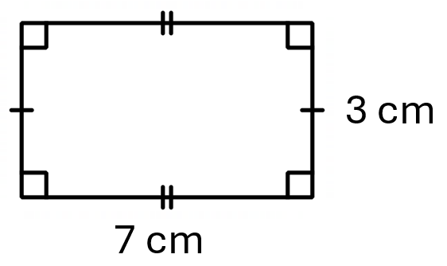
- Consider the rectangle to the right.
  - Calculate the area of this triangle, giving answer in cm².
21 cm²
  - Convert your answer mm².
21 cm² $×{10}^{2}=$ 2100 mm²
  - Redo the calculation by first converting 3 cm and 7 cm to mm, then calculate the area, giving answer in mm².
30 mm x 70 mm = 2100 mm²
  - When doing area calculations, does it matter if you first convert the lengths or convert the area at the end? Which do you prefer?

Students tend to make mistakes converting units of area, so Mr Ding recommends you convert lengths before calculating area.
- Calculate the area of a rectangle with dimensions 12 cm and 0.2 m.
Answer in an appropriate unit.

240 cm²
- A student writes: “To convert cm² to m², I divide by 100 because there are 100 cm in a metre.”
Explain the error. What should the student divide by?

There are 100 cm in 1 m, but 10 000 cm² in 1 m².
Each dimension scales by 100, so the area scales by 100² = 10 000. Divide by 10 000.

- Two students compare answers:
Aaliya says: 3.5 m² = 35 000 cm²
Ben says: 3.5 m² = 3 500 cm²
Who is correct? Show working to justify your answer

Aaliya. 3.5 × 10 000 = 35 000 cm².
- A student is measuring tiles. Each tile is a square with side 20 cm.
How many tiles are needed to cover 1 m²? Show your working using area, not counting

Area of 1 tile = 20 × 20 = 400 cm²
Area of 1 m² = 10 000 cm²
Number of tiles = 10 000 ÷ 400 = 25 tiles
- The conversion factor from m to km is ÷ 1 000.
Explain why the conversion factor from m² to km² is not ÷ 1 000.

Because area involves two dimensions.
A square of 1 km side contains 1 000 × 1 000 = 1 000 000 m².
So 1 km² = 1 000 000 m², and the conversion factor is ÷ 1 000 000 = ÷ 1000².

- A rural property is rectangular in shape with sides 350 m and 500 m.
  - Find its area in square metres and then in hectares.

175 000 m² = 17.5 ha
  - The owner wants to plant 8 mangroves per ha, how many trees should be planted?

140 trees
- A bathroom floor measures 2.4 m by 1.8 m. Square tiles have side length 30 cm.
  - Find the area of the floor in cm².
  - Find the area of one tile in cm².
  - How many tiles are needed?

240 × 180 = 43 200 cm²
30 × 30 = 900 cm²
43 200 ÷ 900 = 48 tiles
- A national park covers 45 km².
  - Convert to hectares.
  - Convert to m².
  - A ranger says “I patrol about 500 ha each day.”
How many days would it take to patrol the entire park?
45 × 100 = 4 500 ha
45 × 1 000 000 = 45 000 000 m²
4 500 ÷ 500 = 9 days

Mastery
- A suburban home is advertised as 650 m².
  - Express this in hectares.
  - A nearby farm is 3.2 ha. How many suburban homes could fit on the farm?

650 ÷ 10 000 = 0.065 ha
3.2 ha = 32 000 m². 32 000 ÷ 650 ≈ 49 blocks (49.2… so 49 complete blocks)
- A football oval has area 18 000 m².
  - Express in ha.
  - A groundskeeper applies fertiliser at a rate of 1 bag per 500 m². How many bags are needed?
  - Each bag costs $12. Find the total cost.

18 000 ÷ 10 000 = 1.8 ha
18 000 ÷ 500 = 36 bags
36 × $12 = $432

- Rebecca is tiling her kitchen floor. The floor is a rectangle, measuring 8 m by 6 m.
Each tile is a square measuring 20 cm by 20 cm.
The tiles are sold in boxes of 10 and each box costs $8.50.
Work out the total cost of the tiles needed for the kitchen floor.

Area of kitchen = 48 m² = 480 000 cm²
Area of tile = 400 cm²
Number of tiles needed = $480 000÷400=1200$
Number of boxes needed = $120$
Total cost = $120×\$8.50=\$1020$
- Fill in the table.
Shape | Area in square m | Area in square cm | Area in square mm
 | 14 | 140 000 | 14 000 000
 | 18 | 180 000 | 18 000 000
 | 15 | 150 000 | 15 000 000
4 m | 20 | 200 000 cm² | 20 000 000
? m  3 m  7 m  2 m  6 m  3 m  5 m  3 m  5 m  ? m  7 m | 21 | 210 000 | 21 000 000 mm²
11 m  ? m  0.2 | 2.2 m² | 22 000 | 2 200 000

Area of Squares and Rectangles

- Review
- Recall units of area.
- A length is measured in centimetres.  What unit do we use for area? | - A length is measured in millimetres.  What unit do we use for area? | - A length is measured in metres.  What unit do we use for area?

- Calculate the area of these shapes. Answer in cm².
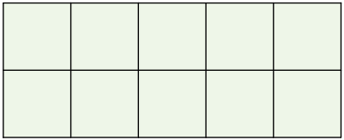 | 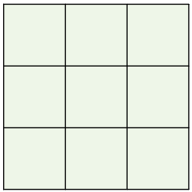 |  | 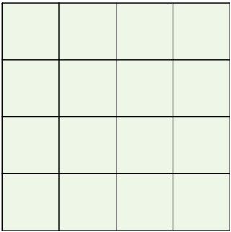
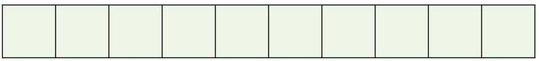 |  | 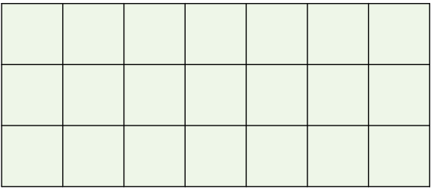

- Area of a Rectangle and Square
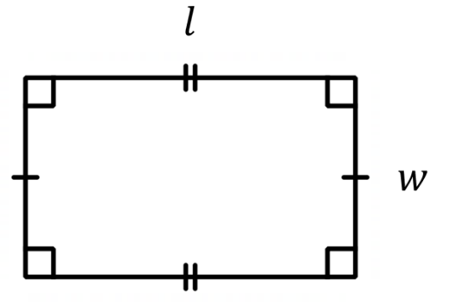  Area of a Rectangle  $$A=lw$$ | 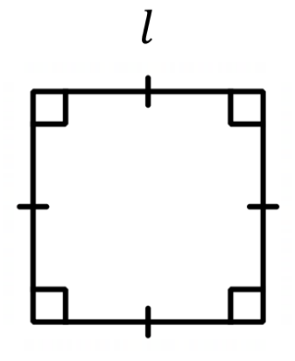  Area of a Square  $$A=l^{2}$$

- Example Calculate area of a rectangle and square
Calculate the area of these shapes.
$A=lw$  $=9×4$  $=36$ mm²  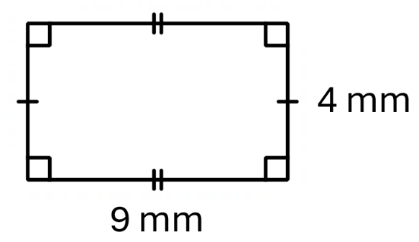 | $A=5^{2}$  $=5×5$  $=25$ cm²  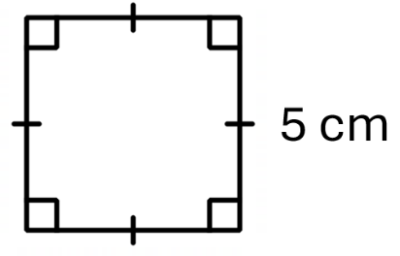

- Guided Practice
Calculate the area of these shapes.
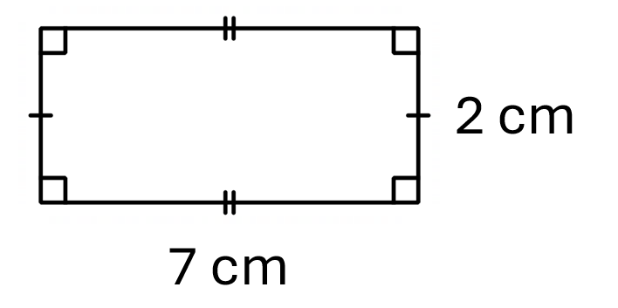  14 cm² | 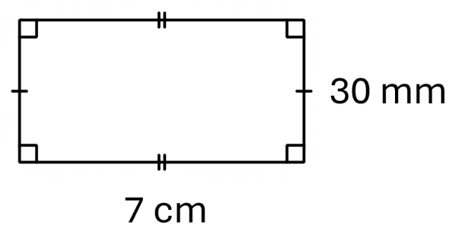  21 cm² or 2100 mm²
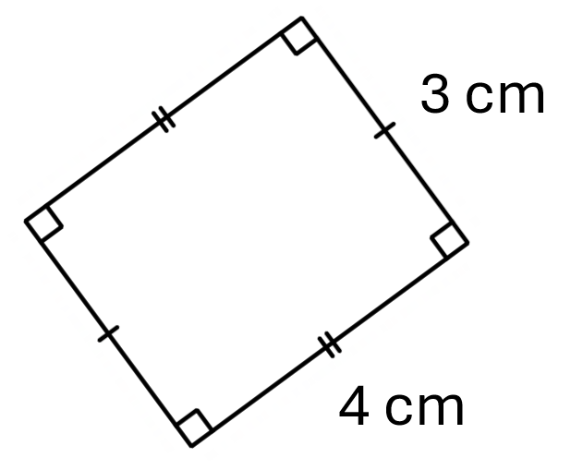  12 cm² | 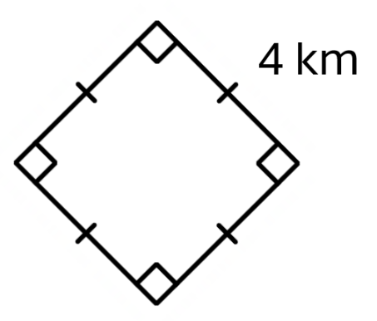  16 km²

- Key Ideas
- The area of a rectangle is $A=$ ……… $×$ ………
- We measure area in …………… units, such as cm² and m².
- A square is a rectangle with all sides equal, so $A=$ ……… $×$ ……… $=$ ……

Foundation
- Calculate the area of these rectangles and squares.
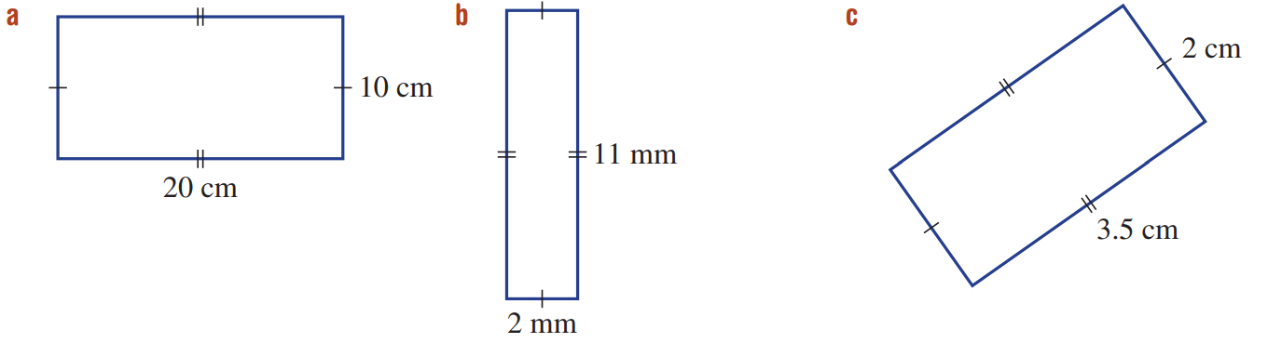  $A=lw$  $=$ …… $×$ ……  $=$ ……… cm²  200 cm² | $A=lw$  $=$ …… $×$ ……  $=$ ……… ………  22 mm² | 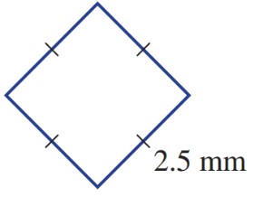  $A=$ ………  $=$ …… $×$ ……  $=$ ……… ………  6.25 mm²
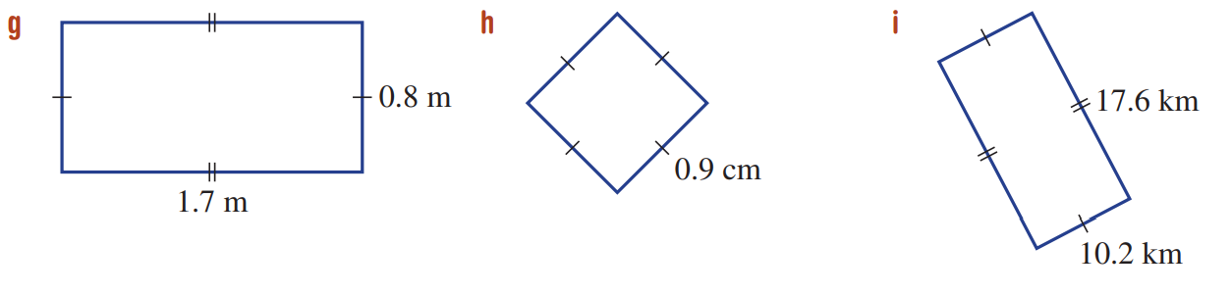  1.36 m² | 0.81 cm² | 179.52 km²

- A rectangular soccer field needs new grass. The field is 100 m long and 50 m wide.
Find the area of grass to be laid down.

5000 m²
- Glass is to be cut for a square window of side length 50 cm.
Find the area of glass required for the window.
2500 cm²
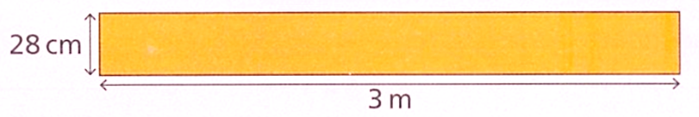

Ava says:
The area of the rectangle is 28 x 3 = 84 cm²

Explain why Ava is incorrect.
The units are different
Find the area of the rectangle in cm²
8400 cm²
Find the area of the rectangle in m²
0.84 m²

Development
- Calculate the area of these shapes. Give your answer in the smaller unit.
306 cm² | 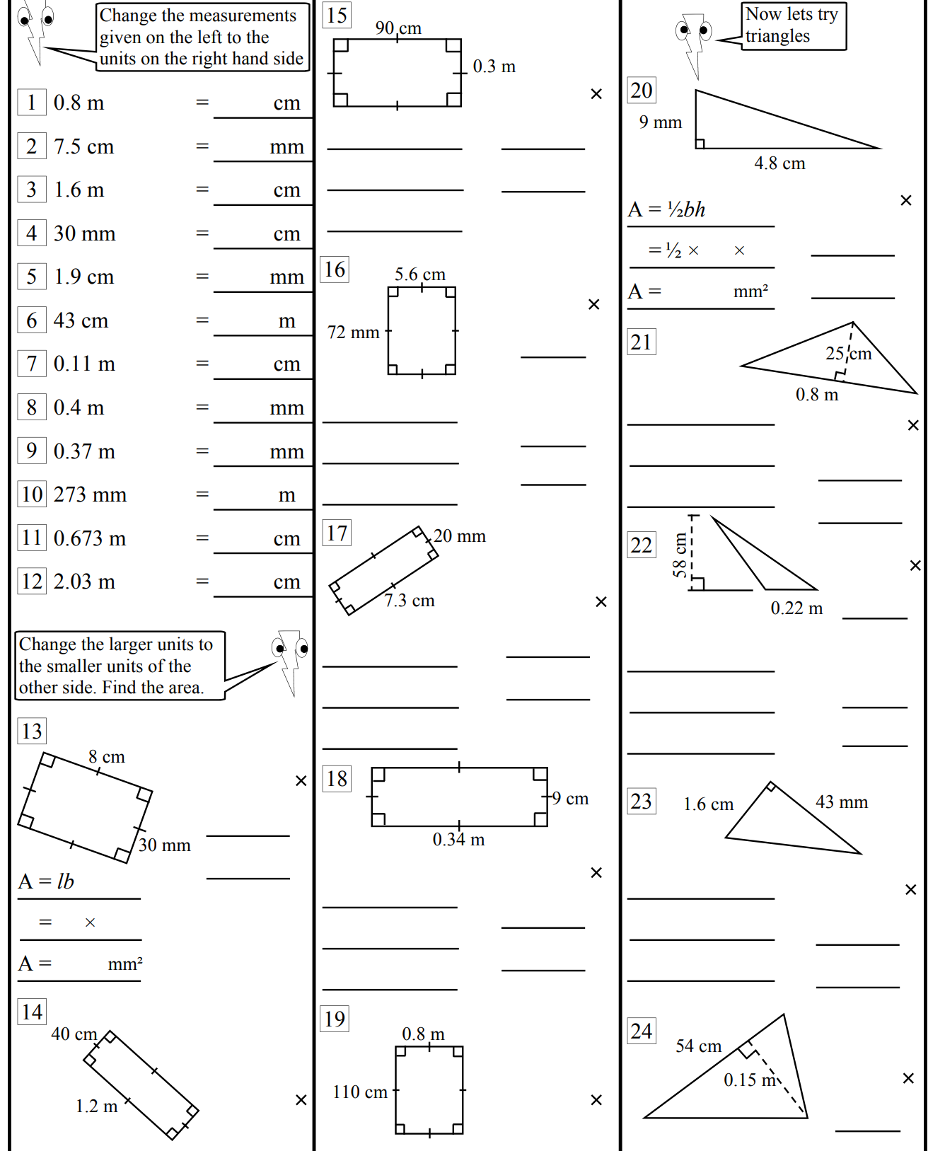  8800 cm² | 4800 cm²

- Which of these rectangles fits all these criteria?
The smallest length is less than 5 cm.
The area is more than 20 cm².
The perimeter is equal to 32 cm.
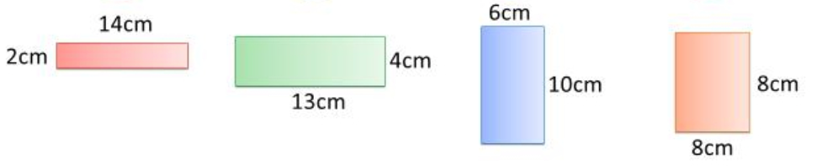

The left most rectangle
- Complete the table:
 | Rectangle | Area | Change
 | 4 cm × 6 cm | 24 cm² | —
 | 8 cm × 6 cm | 48 cm² | Length doubled → area doubled
 | 4 cm × 12 cm | 48 cm² | Width doubled → area ……………
 | 8 cm × 12 cm | 96 cm² | Both doubled → area ……………
 | 2 cm × 6 cm | 12 cm² | Length halved → area halved
 | 4 cm × 3 cm | 12 cm² | Width halved → area halved
 | 2 cm × 3 cm | 6 cm² | Both halved → area ×¼

- A square has side length 5 cm. A rectangle has length 7 cm and width 3 cm.
  - Find both areas.
  - Which has the larger area?
  - Which has the larger perimeter?
  - Can a shape have a larger area but smaller perimeter than another shape?

Square: 25 cm². Rectangle: 21 cm²
Square
Rectangle: 20 cm. Square: 20 cm. Same perimeter.
Yes, the square and rectangle here have the same perimeter but different areas.

- These rectangles have the same perimeter of 30 cm.
For each rectangle, calculate the missing side, then calculate the area.
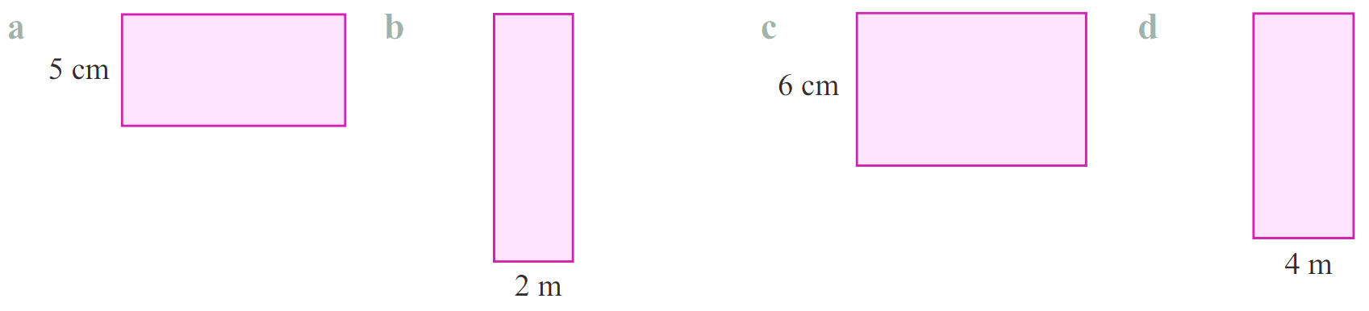  10 cm, 50 cm² | 13 m, 26 m² | 9 cm, 54 cm² | 11 m, 44 m²
Does having the same perimeter mean having the same area?
no

- A rectangle has length 9 cm and width 4 cm.
  - Find the area.
  - The length increases by 1 cm. By how much does the area increase?
  - The width increases by 1 cm instead. By how much does the area increase?
  - Which dimension gives a greater area increase when increased by 1 cm?
  - Should you increase the smaller dimension or the larger dimension to get the greatest area increase?
36 cm²
10 × 4 = 40 cm². Increase = 4 cm²
9 × 5 = 45 cm². Increase = 9 cm²
Increasing the larger dimension (length) gives a smaller increase.

Increasing the smaller dimension gives a larger increase.

- A square courtyard has area 196 m².
  - Find the side length of the courtyard.
  - Find the perimeter.
  - Fencing costs $45 per metre. Find the cost of fencing the entire perimeter.
$\sqrt{196}= 14$ m
4 × 14 = 56 m
56 × $45 = $2520

- A rectangular car park is 80 m long and 45 m wide. Each parking space is a rectangle 2.5 m wide and 5 m long.
  - Find the area of the car park.
  - Find the area of one parking space.
  - Estimate the maximum number of spaces (ignore lanes and markings).
80 × 45 = 3 600 m²
2.5 × 5 = 12.5 m²
3 600 ÷ 12.5 = 288 spaces

- A student says: “If I triple both sides of a rectangle, the area triples.”
Show with an example that this is wrong. What is the correct multiplier?

Example: 3 and 4.
Original area: $3×4=12$

New sides: 9 and 12
New area: $9×12=108$
The new area multiples by 9 times, or 3² times.

  - A square has a perimeter of 20 cm. Find its area.
Each side is 5 cm, Area = 25 cm²
  - A square has an area of 9 square centimetres. Find its perimeter.
Each side is 3 cm, Area = 9 cm²
  - A square’s area and perimeter are the same number. How many units is the side length?

4 cm

Mastery
- A rectangle has area 72 cm². The lengths of the sides are integers,
  - Find the possible lengths of the sides of the rectangle in centimetres,
1 and 72, 2 and 36, 3 and 24, 4 and 18, 6 and 12, 8 and 9 cm
  - What is the connection to the factors of 72?
The possible side lengths are factor pairs of 72.

- A rectangle has perimeter 20 cm. Both the length and width are whole numbers.
List all possible rectangles and their areas. Which has the largest area?

Pairs (l, w) with l + w = 10:
(9,1)=9, (8,2)=16, (7,3)=21, (6,4)=24, (5,5)=25.
The 5 × 5 square has the largest area.

- A photo is 15 cm wide and 20 cm long. It is placed in the centre of a square frame with side length 28 cm.
  - Find the area of the photo.
  - Find the area of the frame (the border region only).
  - The border is painted gold. Gold paint covers 250 cm² per tube. How many tubes are needed?

15 × 20 = 300 cm²
28² − 300 = 784 − 300 = 484 cm²
484 ÷ 250 = 1.936 → 2 tubes

  - A square has all its side lengths doubled. Explain why the area does NOT double.
(Hint: Draw a diagram.)

A square with sides $x$ cm has area $x^{2}$ cm² , a square with $2x$ cm has area $4x^{2}$ cm²
  - How much as large would the area of a square be if the lengths were tripled?

9 times larger
  - If you want a square to be 16 times as large, how would you need to change the side lengths?

The sides need to be 4 times as long
- Vince has a rectangular piece of scrap paper. He decides to cut a quarter of the rectangle off, and places it over the remaining paper to make a new shape, as shown.
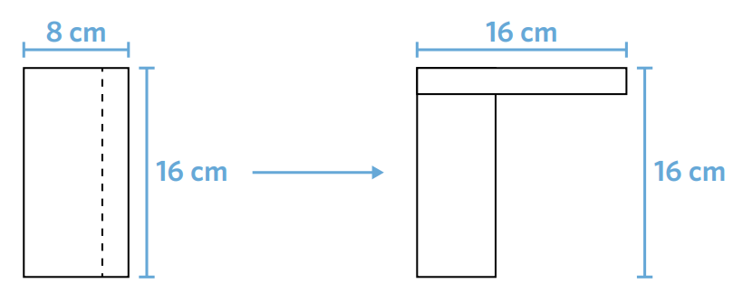
What is the perimeter of this new shape?

64 cm
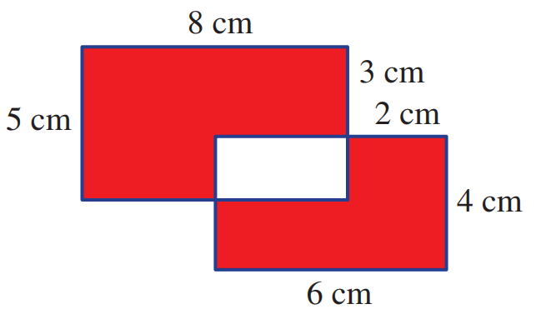
- These two rectangles overlap, as shown. Find the total area of the shaded region.

Area of larger rectangle: $5×8$
Area of smaller rectangle: $4×6$
Area of overlapping region: $4×2$
$$A=\left(5×8\right)+\left(4×6\right)-2\left(4×2\right)$$
= 48 cm²
- Four identical rectangles are placed together to make one large rectangle.
The area of the large rectangle is 192 cm².
The length of one of the smaller rectangles is 3 times the width.
Work out the length and width of the large rectangle.
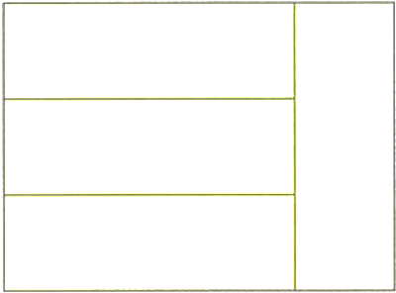

Area of small rectangle is $192÷4=48$ cm²
The small rectangle has lengths $x$ and $3x$, so the area is $3x^{2}=48$
$x=4$ cm
The lengths of the larger rectangle is 12 cm and 16 cm

Area of Parallelograms

- Identify Parallelograms
A parallelogram is a four-sided shape with two pairs of parallel sides.
✖  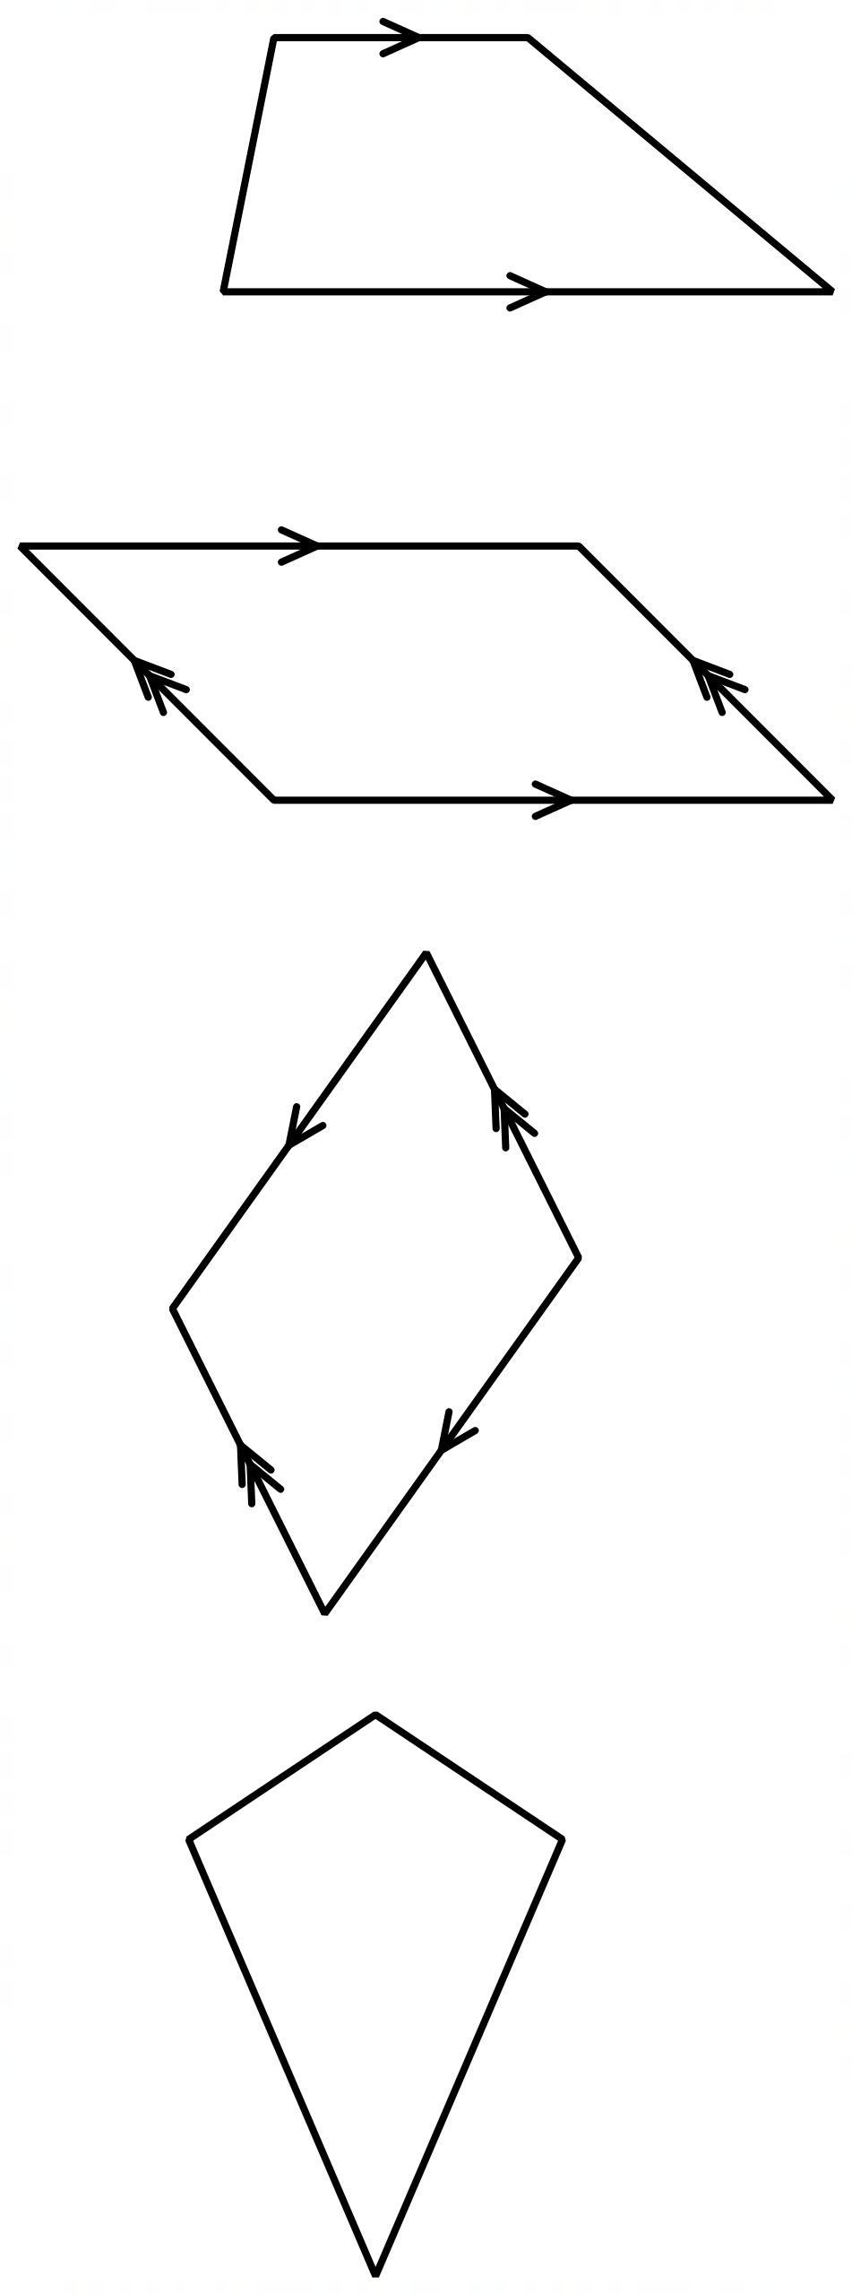 | ✔ |  | ✔  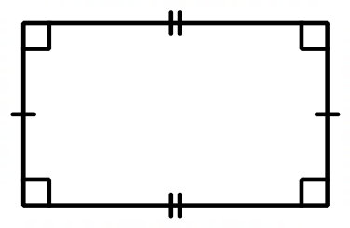 | ✔ |  | ✖
Decide whether these shapes are parallelograms.
 |  |  |  |  | 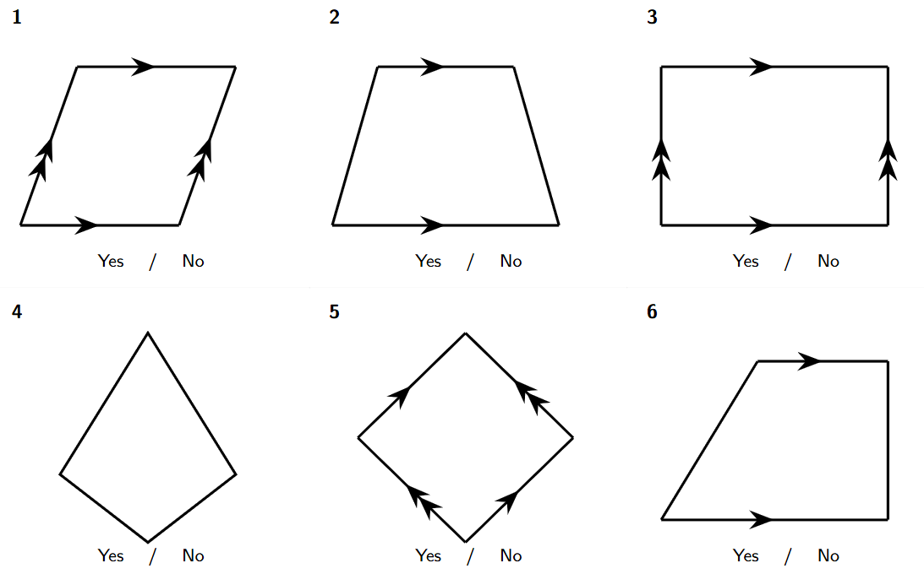

- Base and Height of a Parallelogram
The base is any side of a parallelogram.
The height is the perpendicular $(90°)$ distance from the base to the opposite side.
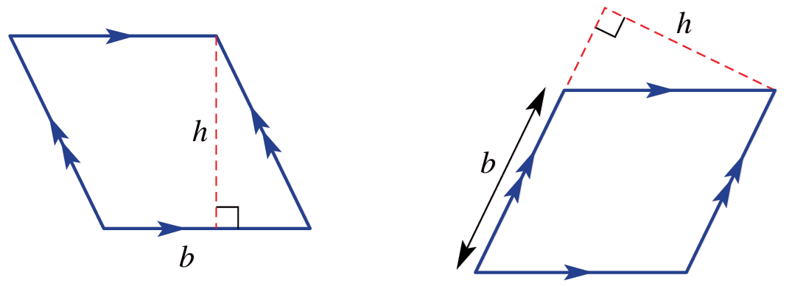

- Identify base and height of a trapezium
Identify the base and height in these parallelograms.
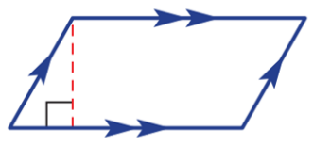
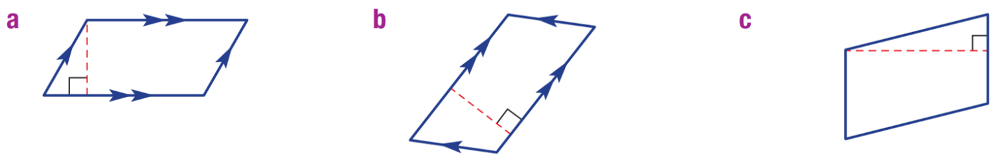

 |  | 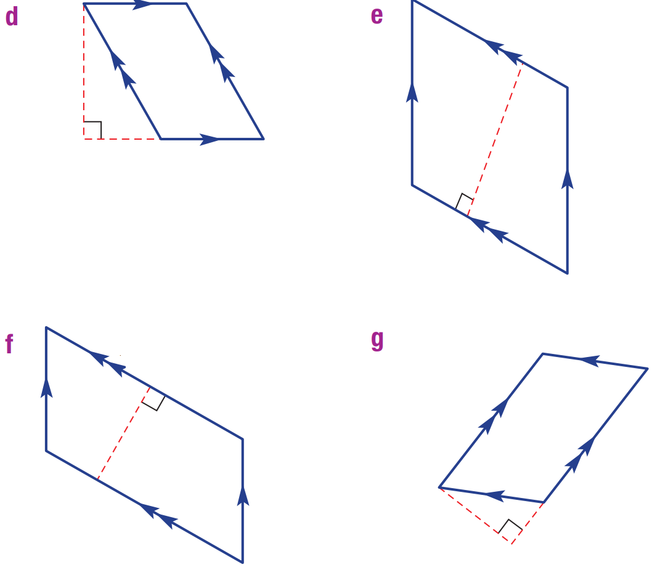
Show the perpendicular length on these parallelograms.
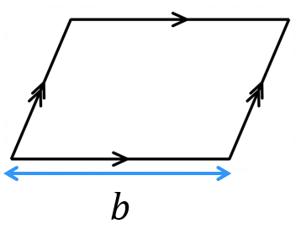 | 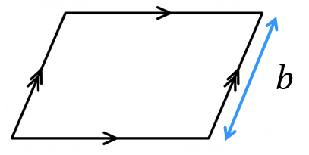 | 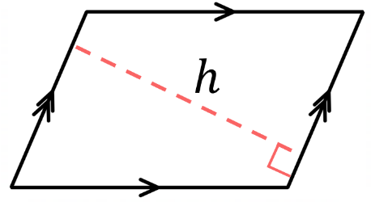
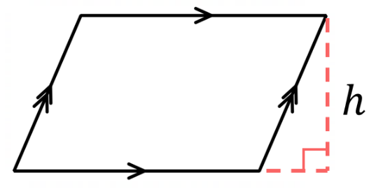 | 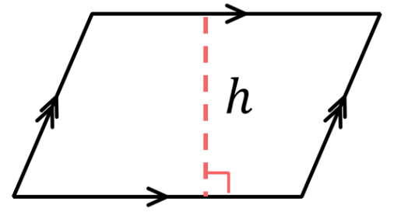 | 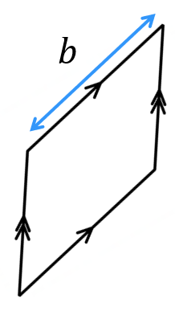

- Key Ideas
- The base is ……… side of the parallelogram. The height is at …… degrees to the base.
- Area of a Parallelogram
A parallelogram has the same area as a rectangle with the same base and height.

$A=bh$

- Area of a Parallelogram: https://www.geogebra.org/m/drzqkwdc

- Example Calculate the area of a parallelogram
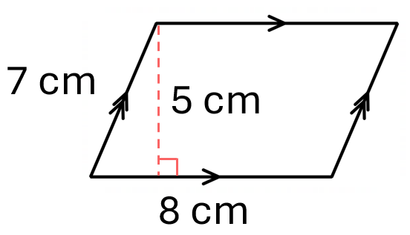  $A=bh$  $=8×5$  $=40$ cm² | 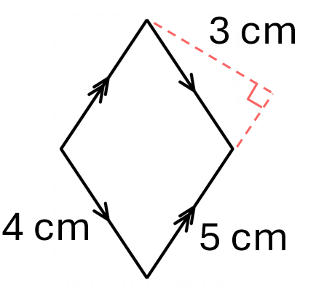  $A=bh$  $=5×3$  $=15$ cm²

- Guided Practice
Calculate the area of these parallelograms.
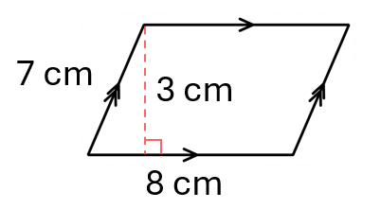  24 cm² | 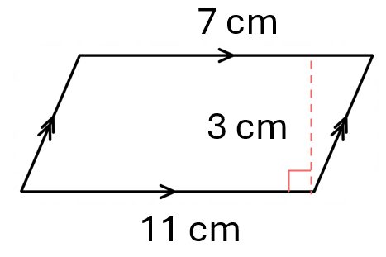  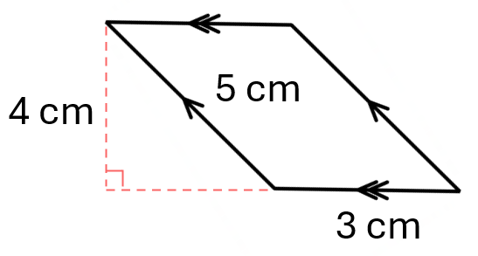  33 cm²
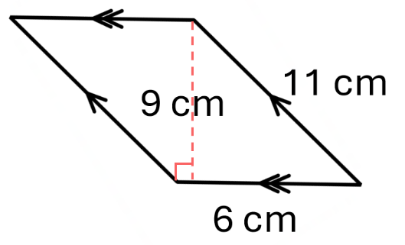  54 cm² | 12 cm²

- Key Ideas
- The area of a parallelogram is found using A = …………… × ……………
- The base and height of a parallelogram are always ………………… to each other (at 90°).

Foundation
- Calculate the area of these parallelograms.
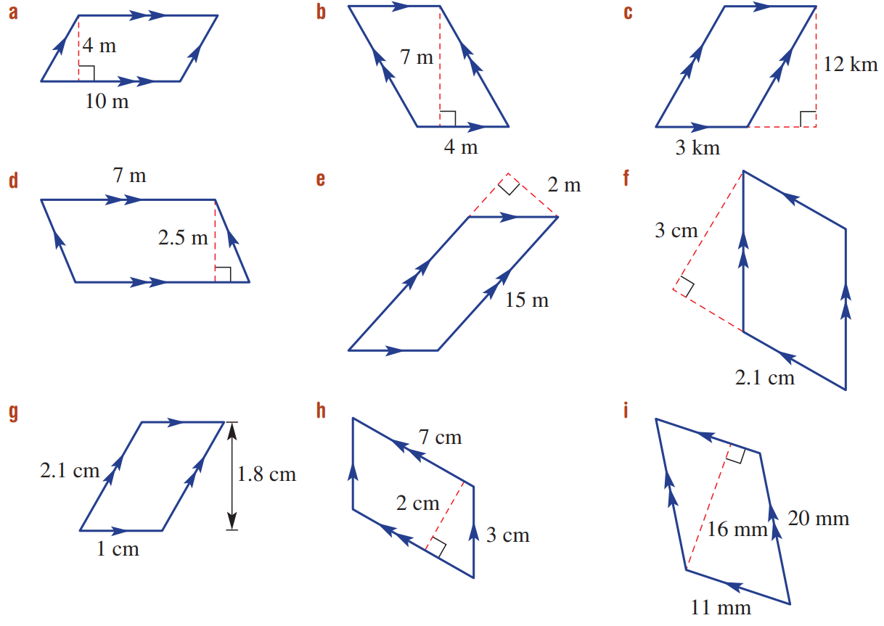  $A=bh$  $=$ …… $×$ ……  $=$ ……… m²  40 m² | 28 m² | 36 km²
17.5 m² | 30 m² | 6.3 cm²

- Calculate the area of these shapes. Give your answer in the smaller unit.
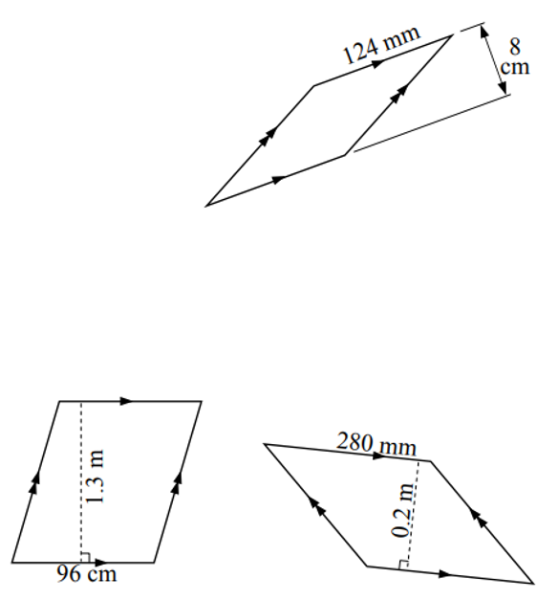  9920 mm² | 12 480 cm² | 56 000 mm²

Development
- Calculate the area of these parallelograms.
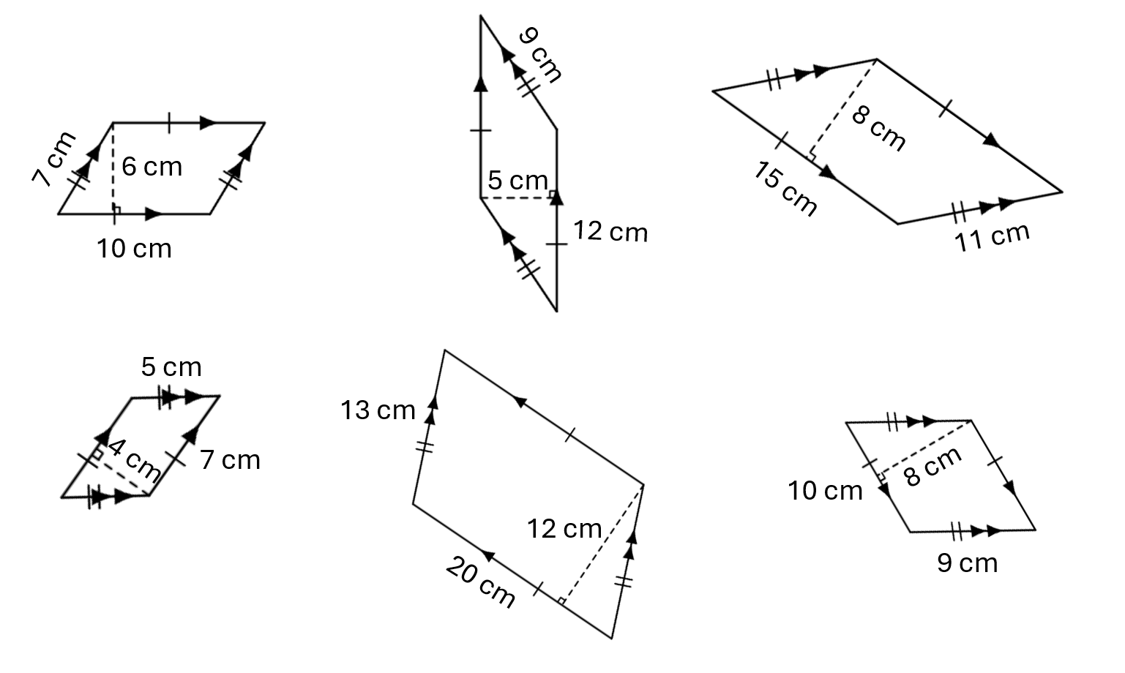  60 cm² | 60 cm² | 120 cm²
32 cm² | 240 cm² | 80 cm²
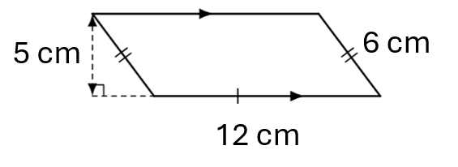  60 cm² | 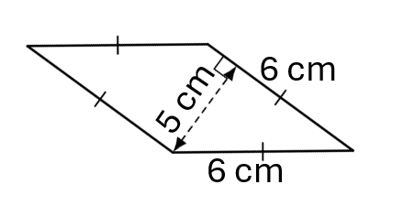  30 cm² | 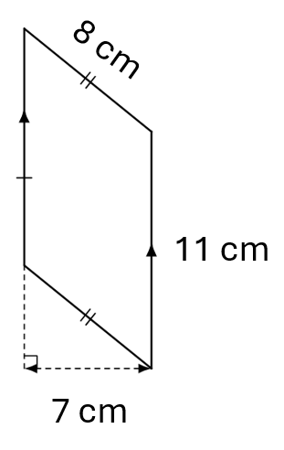  77 cm²

- Calculate the area of these parallelograms.
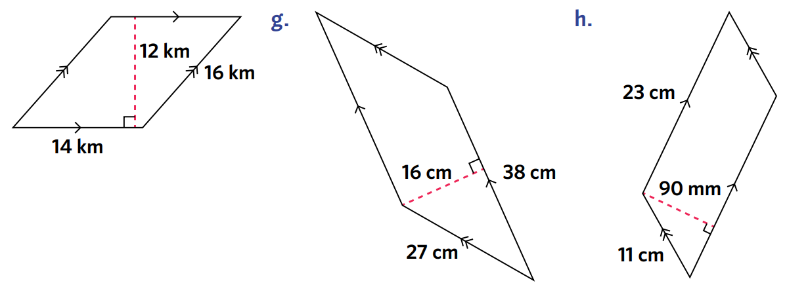  168 km² | 608 cm² | 20 700 mm²
1.8 cm² | 14 cm² | 176 mm²

- A large wall in the shape of a parallelogram is to be painted, which costs $20 per litre.
The wall has a base length of 30 m and a height of 10 m.
Each litre of paint covers 5 m².
Find the cost of painting the wall.

$1200
- The base of a parallelogram is three times its height. The area is 75 cm².
Find the base and height.
Let $h$= height,
$$b = 3h$$

$$A = bh$$
$$75 = 3h × h$$
$$75 = 3h²$$
$$h² = 25,$$
$$h = 5 cm$$
$$b = 15 cm$$

Area of Triangles

- Review
- Evaluate expressions involving fractions
$$\frac{8×3}{2}$$ | $$\frac{1}{2}\left(8×3\right)$$ | $$\frac{5\left(6\right)}{2}$$

- Base and Height of a Triangle
The base is any side of a triangle.
The height is the perpendicular $(90°)$ distance from the base to the opposite vertex.
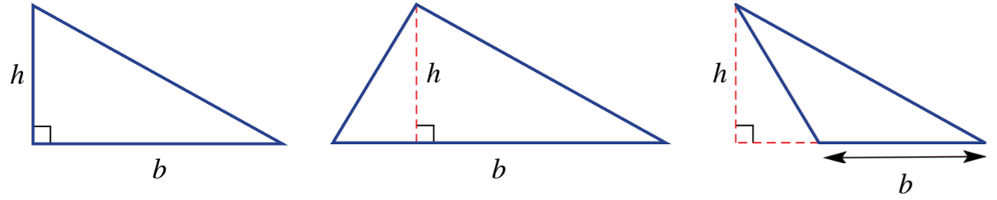

- Identify base and height of a triangle
Label the base and height of each triangle.
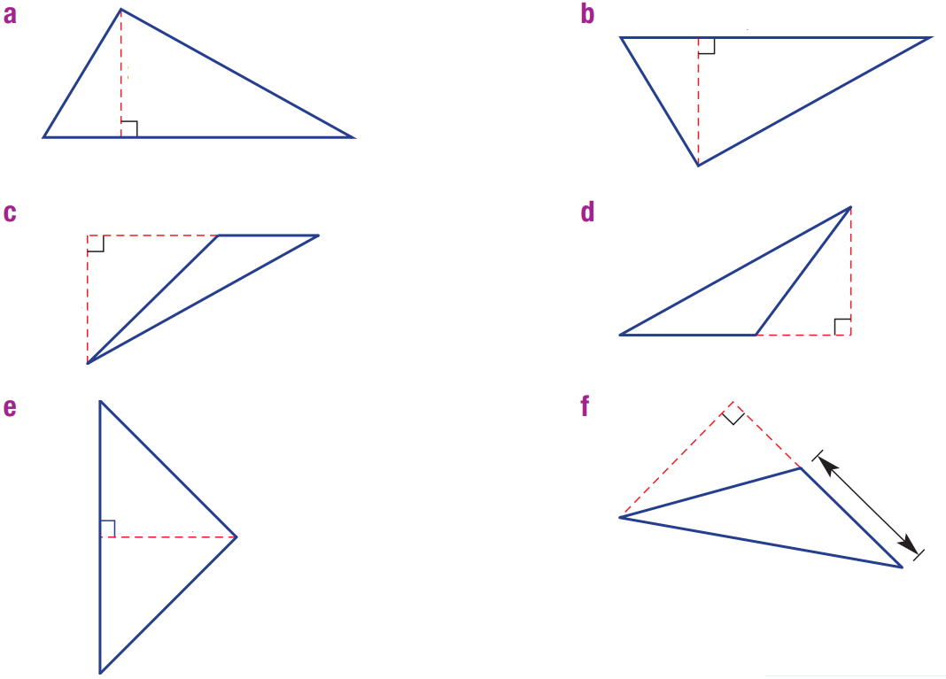

- Area of a Triangle
A triangle has half the area of a parallelogram with the same base and height.

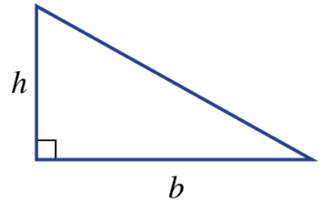
$$A=\frac{bh}{2}$$

- Area of a Triangle: https://www.geogebra.org/m/uxgykeuz

- Example Calculate area of a triangle
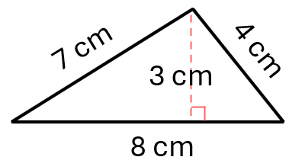  $$A=\frac{bh}{2} \\ =\frac{8\left(3\right)}{2} \\ =12 {cm}^{2}$$ | 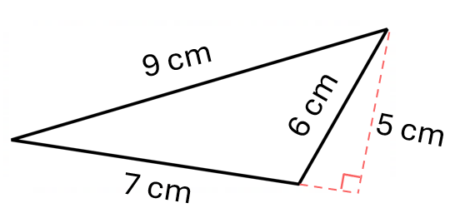  $$A=\frac{bh}{2} \\ =\frac{7\left(5\right)}{2} \\ =17.5 {cm}^{2}$$

- Guided Practice
Calculate the area of these triangles.
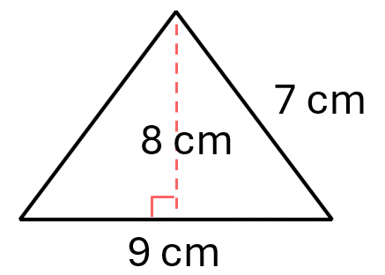  36 cm² | 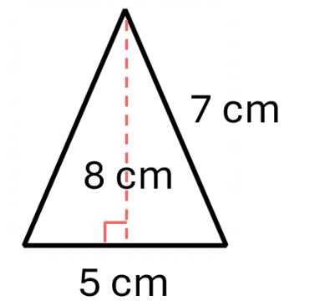  20 cm²
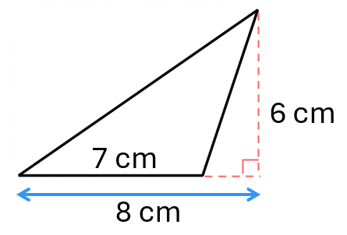  21 cm² | 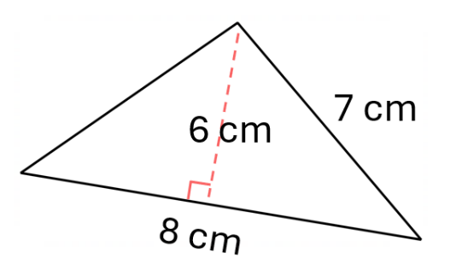  24 cm²

- Key Ideas
- Every triangle is half of a …………………, so its area is $A=$ ………

Foundation
- Calculate the area of each of these triangles.
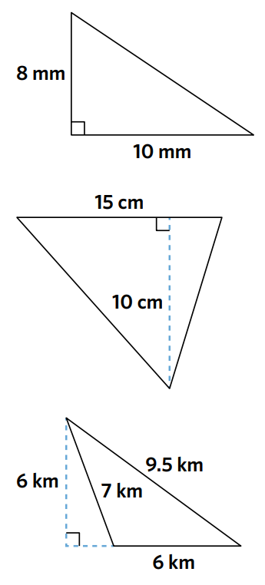  $$A=\frac{bh}{2}$$  $$=\frac{( )×( )}{( )}$$  $=$ ………… mm²  40 mm² | $$A=\frac{bh}{2}$$  $$=\frac{( )×( )}{( )}$$  $=$ ………… ……  75 cm² | $$A=\frac{bh}{2}$$  $$=\frac{}{ }$$  $=$ ………… ……  18 km²

- Calculate the area of these triangles.
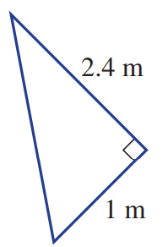  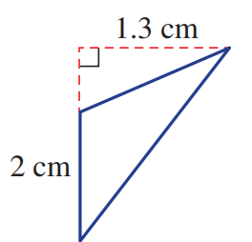  1.2 m² | 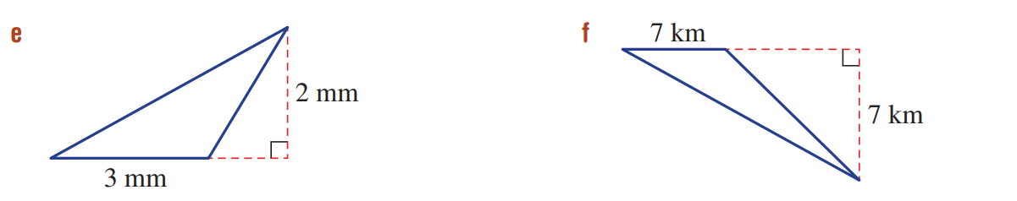  3 mm² | 24.5 km²
1.3 cm² | 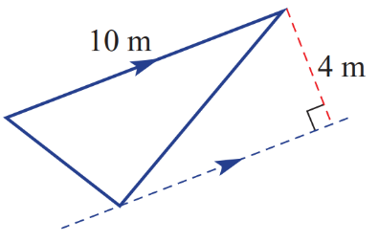  20 m² | 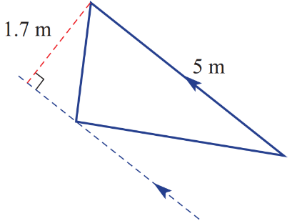  4.25 m²

- A rectangular block of land measuring 40 m long by 24 m wide is cut in half along a diagonal. Find the area of each triangular block of land.

480 m²

Development
- Find the area of these triangles.
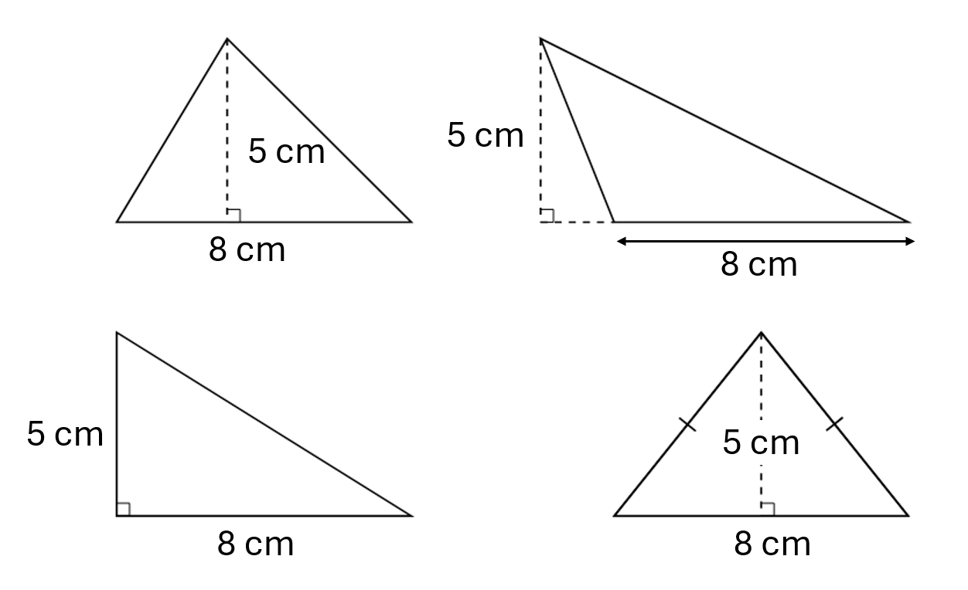  20 cm² | 20 cm²
20 cm² | 20 cm²
Explain why you should’ve gotten the same area for every triangle above.

Base and height are the same for each triangle. So the area would be the same.
- Calculate the area of these shapes. Give your answer in the smaller unit.
1000 cm² | 638 cm² | 344 mm²
- Jimmy calculated the area of this triangle using $\frac{1}{2}$ $×6×7×5$.
Explain why he is incorrect.
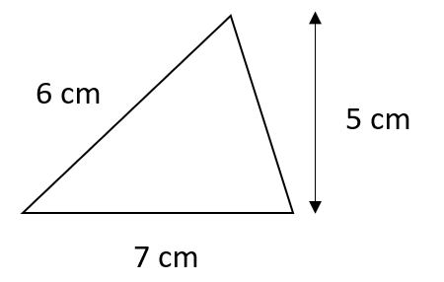

The base and height are 7 and 5. You do not use the 6 cm in the formula.

- Find the area of these triangles.
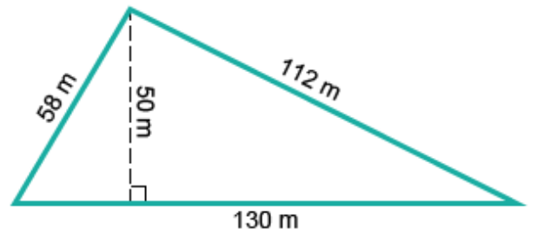  3250 m² | 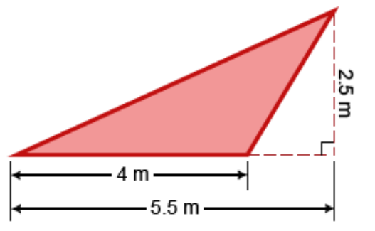  5 m² | 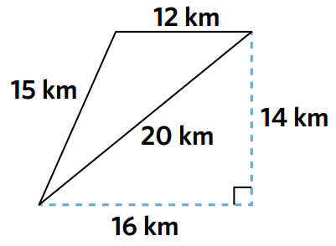  84 km²

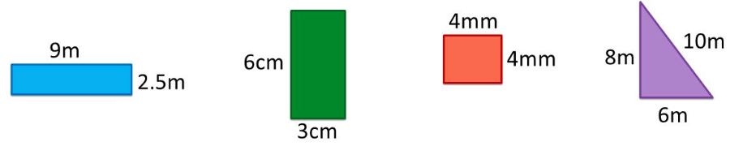
- Which of these shapes does NOT have equal area and perimeter?

The first rectangle.

- Treat this parallelogram as two triangles. Calculate the area of the parallelogram by:
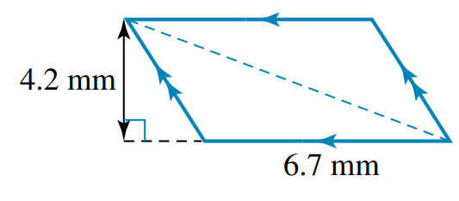
  - Adding the areas of the triangles.

$$\left(\frac{1}{2}×4.2×6.7\right)+\left(\frac{1}{2}×4.2×6.7\right)=28.14 {mm}^{2}$$
  - Using the parallelogram area formula.

$$4.2×6.7 {mm}^{2}$$
- A farmer uses fencing to divide a triangular piece of land into two smaller triangles, as shown. What is the difference in the two areas?
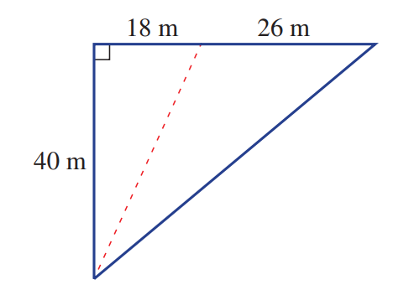

$$\frac{1}{2}\left(40×26\right)-\frac{1}{2}\left(40×18\right)=160 m^{2}$$

Mastery
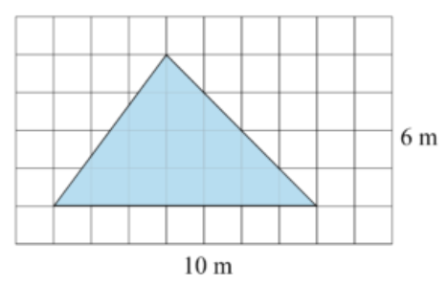
- NAPLAN B+
Jill is playing in her parents' rectangular courtyard.
The courtyard is measured at 6 m by 10 m.
Jill draws a triangle on the courtyard with chalk.
What is the area of this triangle?

$$\frac{1}{2}×7×4=14 m^{2}$$
- The vertex, C, for this triangle moves parallel to the base AB.
Will the area of the triangle change? Justify your answer.
(Hint: Think about the lengths of the base and the height).
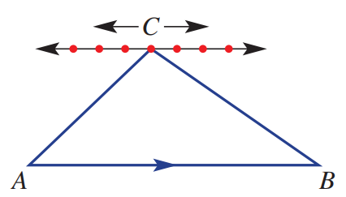

No. The base and height do not change.
- The midpoint, M, of the base of a triangle joins the opposite vertex.
Is the triangle area split in half exactly? Give reasons for your answer.
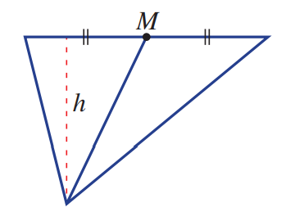

Yes. The heights of both triangles are the same, but the base of the smaller triangle is exactly half the larger one.

Mixed Practice

Foundation
- Calculate the area of each of these shapes using the appropriate formula.
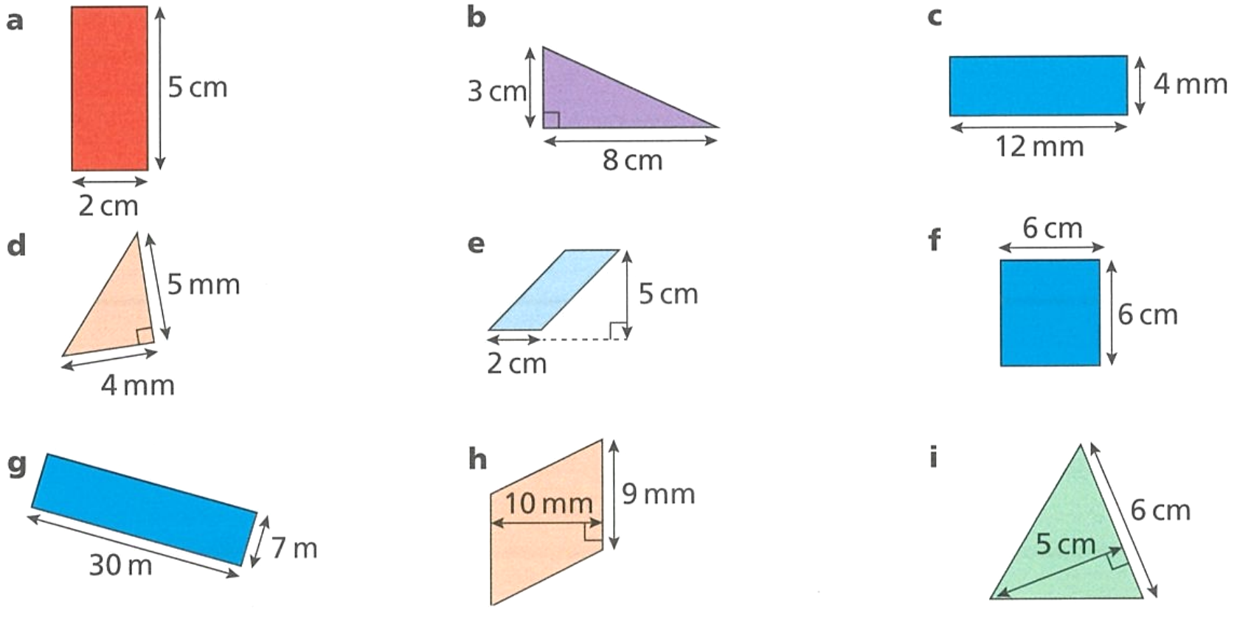  10 cm² | 12 cm² | 48 mm²
10 mm² | 10 cm² | 36 cm²
210 m² | 90 mm² | 15 cm²
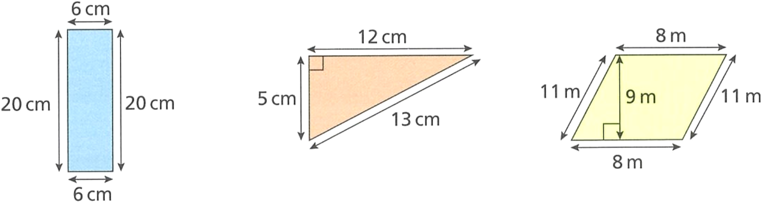  120 cm² | 30 cm² | 72 m²
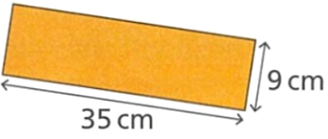  315 cm² | 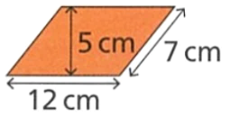  60 cm² | 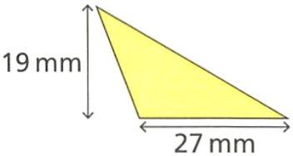  256.5 mm²
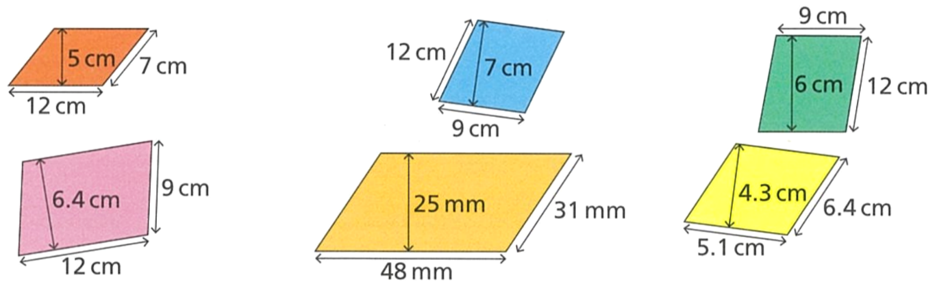  60 cm² | 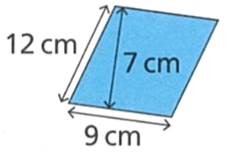  63 cm² | 54 cm²
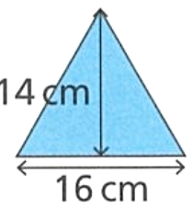  112 cm² | 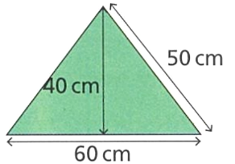  1200 cm² | 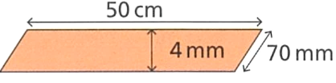  2000 mm²
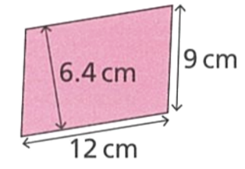  76.8 cm² | 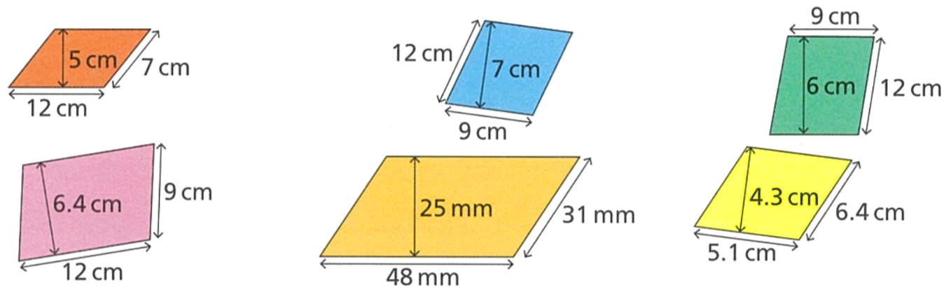  1200 mm² | 21.93 cm²

Area of Composite Figures

- Area of Composite Figures
A composite figure is made up of multiple simple shapes.
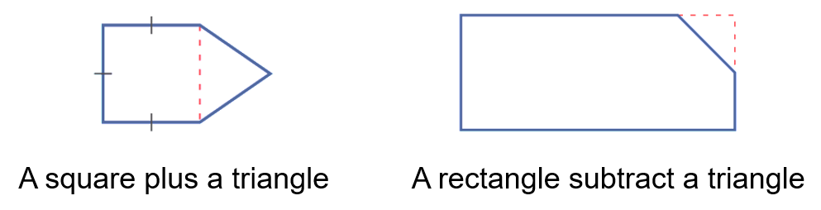

To find the area of composite figures, add or subtract the areas of simple shapes.
- Split the composite figure into squares, rectangles, and triangles.
- Calculate the area of each simple shape.
- Add or subtract the areas.

- Example Calculate area of composite shapes by addition
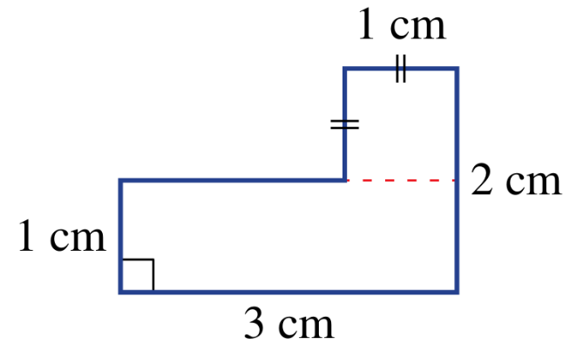  $A_{1}=1×1$  $=1$ cm²  $A_{2}=1×3$  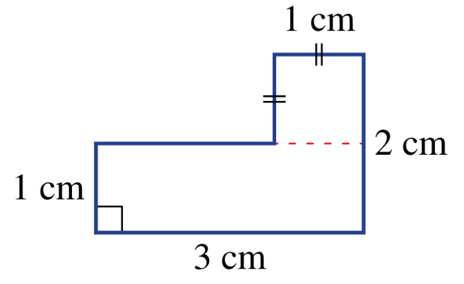  $=3$ cm²  $$A_{1}$$  $$A_{2}$$  $A_{Total}=A_{1}+A_{2}$  $=1+3$  $=4$ cm² | First, we …………… the composite shape into two simple shapes, in this case, a …………… and a ……………  We ……………… the simple shapes $A_{1}$ and $A_{2}$ to show our working clearly.  Then, we calculated the area of each ……………… shape.  Afterwards, we ……………… the areas.

- Guided Practice
Calculate the area of these composite shapes.
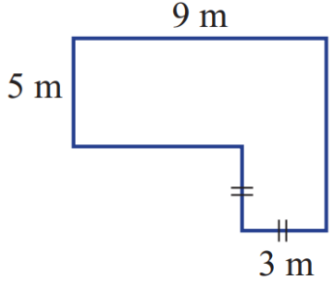  $A_{1}=$  $A_{2}=$  $A_{Total}=$  54 m² | 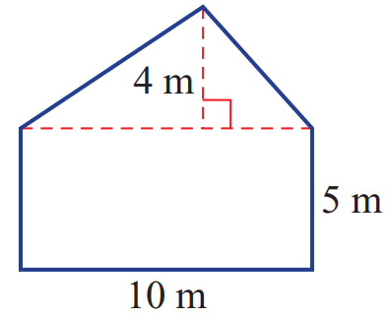  $A_{1}=$  $A_{2}=$  $A_{Total}=$  70 m²
- Example Calculate area of composite shapes by subtraction
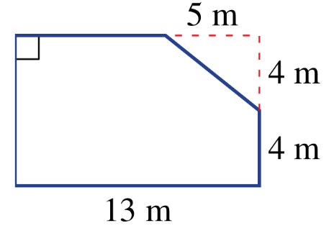  $A_{1}=8×13$  $=104$ m²  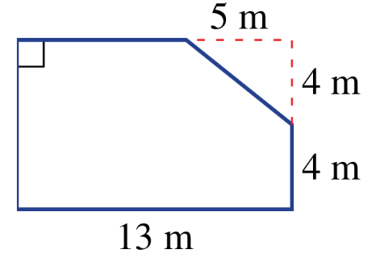  $$A_{2}$$  $$A_{2}$$  $$A_{1}$$  $$A_{2}=\frac{4×5}{2}$$  $=10$ m²  $A_{Total}=A_{1}-A_{2}$  $=104-10$  $=94$ cm² | Draw how you could have found the area of this composite shape by addition.  Why is subtraction the preferred method for finding area of this composite shape?

- Guided Practice
Calculate the area of these composite shapes.
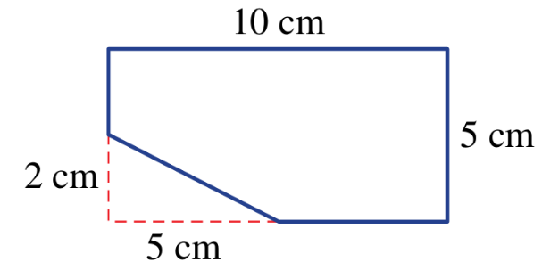  $A_{1}=$  $A_{2}=$  $A_{Total}=$  45 m² | 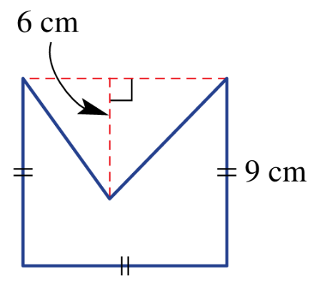  $A_{1}=$  $A_{2}=$  $A_{Total}=$  54 m²

- Key Ideas
- Composite figures are made up two or more simple shapes, such as r………………, s……………, p…………………, and t………………
- First, …………… the composite shape into simple shapes.
- Calculate the area of each of the …………… shapes.
- Add or ……………… the areas, depending on what is more efficient.

Foundation
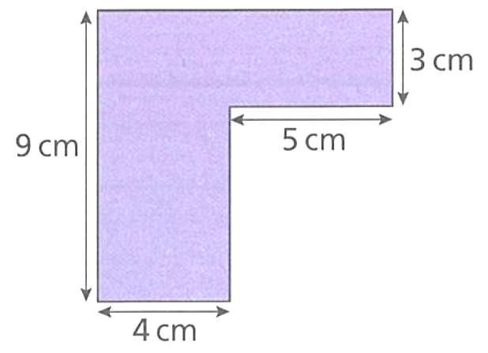
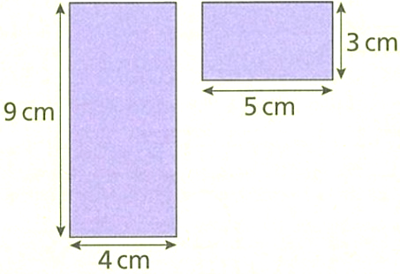
- Calculate the area of this shape.
$$A_{1}$$
$$A_{2}$$

$A=$ $A_{1}$ + $A_{2}$
$=$ ………… + …………
$=$ ………………………
51 cm²

- Calculate the areas of the following shapes by first splitting each into rectangles.
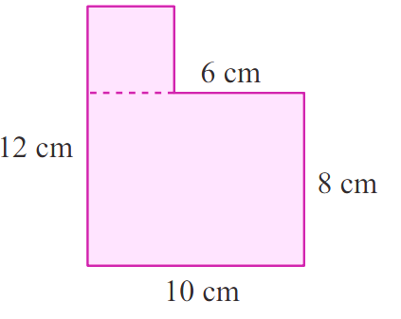  $Total area = Area 1 + Area 2$  $=$ …………+ …………  $=$ ……………………  96 cm² | 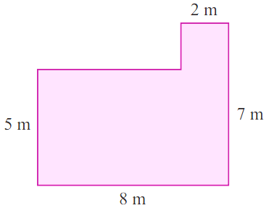  $Total area = Area 1 + Area 2$  $=$ …………+ …………  $=$ ……………………  44 cm²

- Calculate the areas of the following shapes by first splitting each into rectangles.
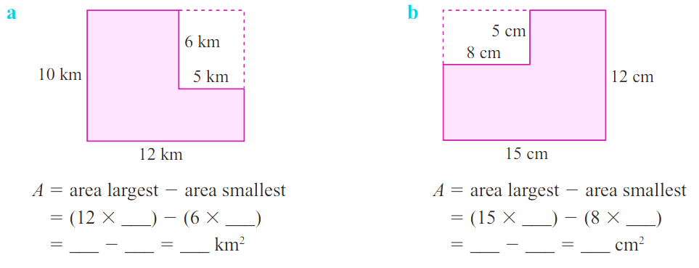  $Total area = Area 1- Area 2$  $=$ …………$-$ …………  $=$ ……………………  90 km² | $Total area = Area 1- Area 2$  $=$ …………$-$ …………  $=$ ……………………  140 cm²

- Calculate the areas of these shapes by splitting them into a triangle and a rectangle.
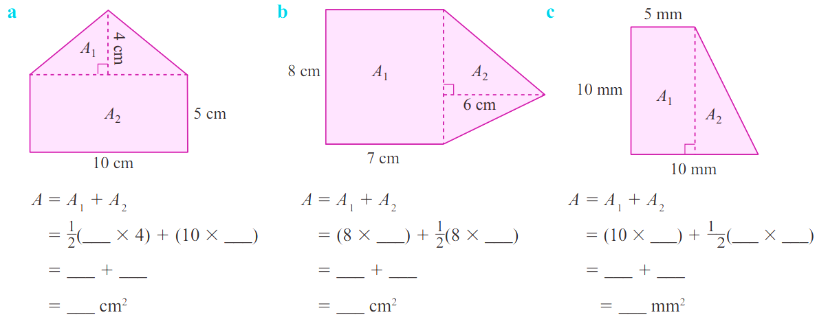  $A_{total}= A_{1} + A_{2}$  $=$ ………… $+$ …………  $=$ ……………………  70 cm² | $A_{total}= A_{1} + A_{2}$  $=$ ………… $+$ …………  $=$ ……………………  80 cm² | $A_{total}= A_{1} + A_{2}$  $=$ ………… $+$ …………  $=$ ……………………  75 mm²

- NAPLAN B+
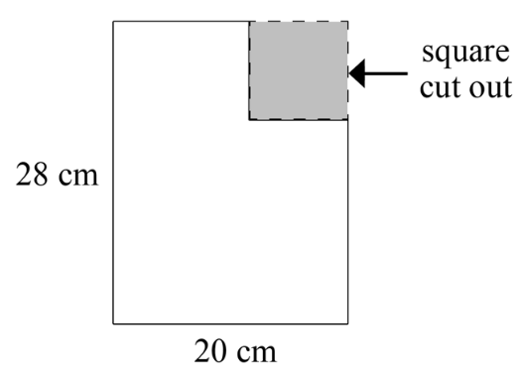
Pablo cuts a square out of a rectangular piece of paper, as shown below.
The square Pablo cut out has a side length of 6 cm.
Which of these expressions gives the area of Pablo's piece of paper after cutting out the square?
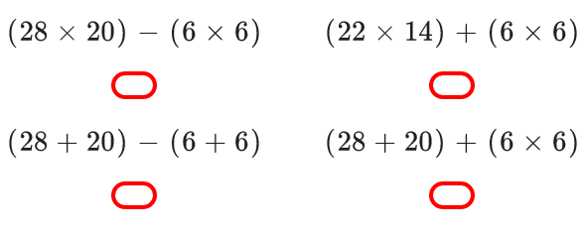

A
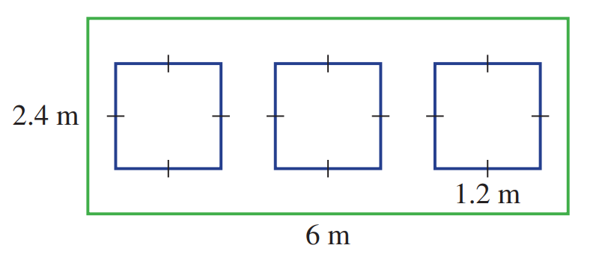
- A wall has three square holes cut into it to allow for windows, as shown.
Find the remaining area of the wall.

10.08 m²

- These three calculations show three ways to find the area of this shape.
Split the shape to represent these calculations.
_________
_________
$$A=12×6+5×4$$ | $$A=10×5+6×7$$ | $$A=12×10-4×7$$  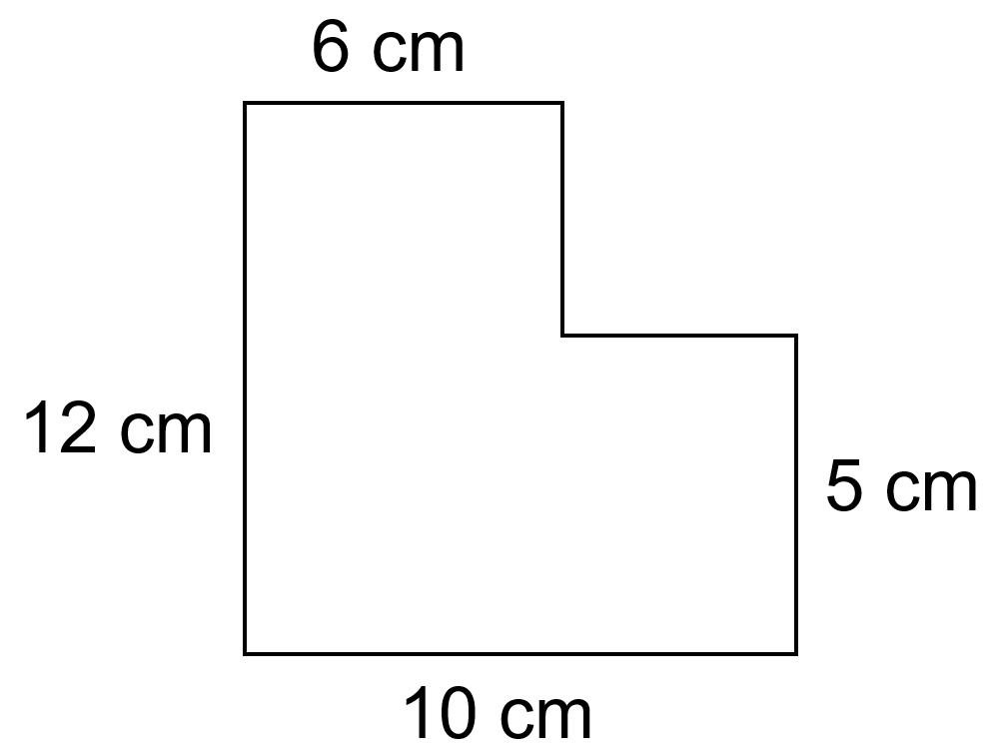  _______  _______

- Calculate the area of the composite shape by two methods. You should get the same answer.
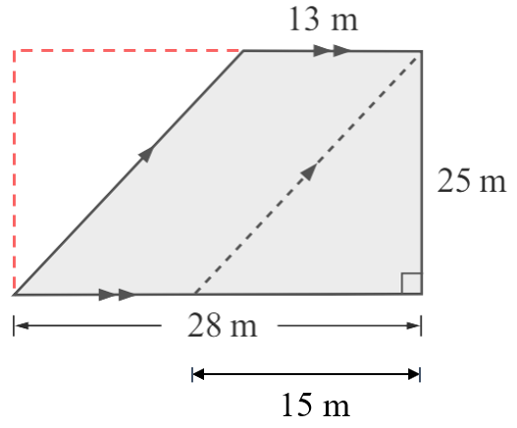
  - Subtraction: Large rectangle subtract triangle.

$$\left(28×25\right)-\left(\frac{1}{2}×15×25\right)=512.5 m^{2}$$
  - Addition: Triangle and parallelogram.

$$\left(\frac{1}{2}×25×13\right)+\left(25×13\right)=512.5 m^{2}$$
- Calculate the area of these composite shapes.
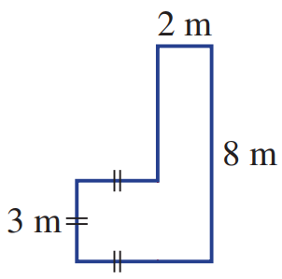  25 m² | 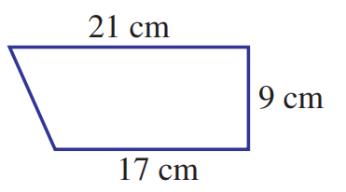  171 cm² | 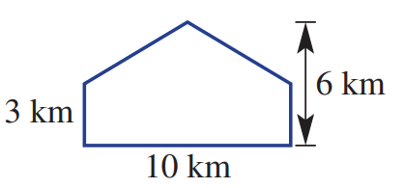  45 km²
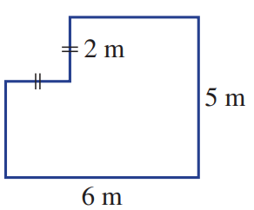  26 m² | 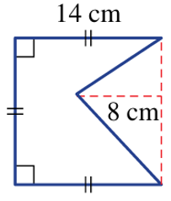  140 cm² | 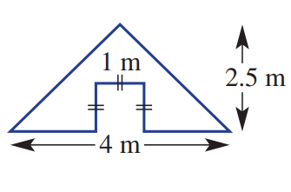  4 m²

Development
- Calculate the area of these shapes.
- Find the shaded area  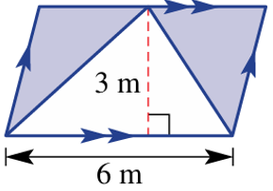  9 m² | 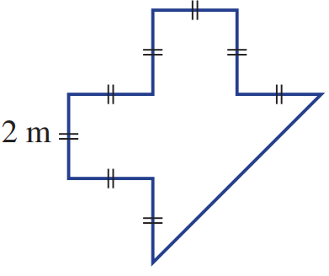  16 m² | 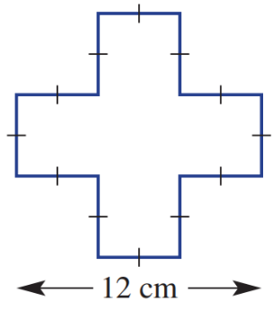  80 cm²
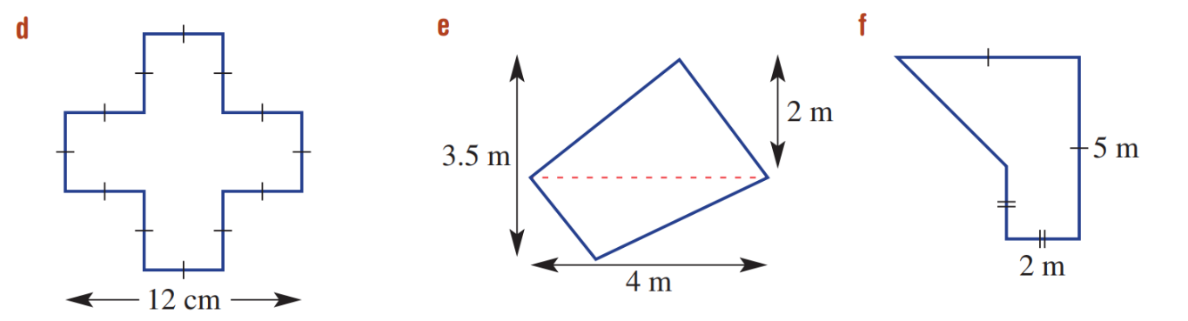  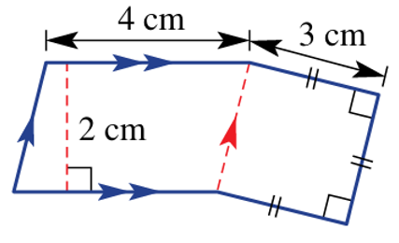  17 cm² | 7 m² | 14.5 m²
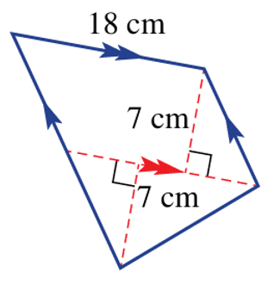  189 cm² | 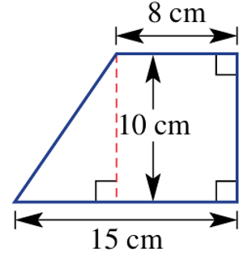  115 cm² | - Find the shaded area  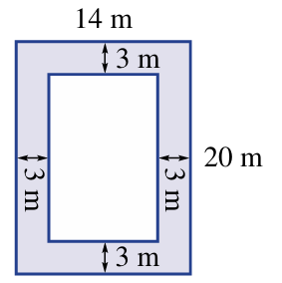  168 m²

- Calculate the shaded area.
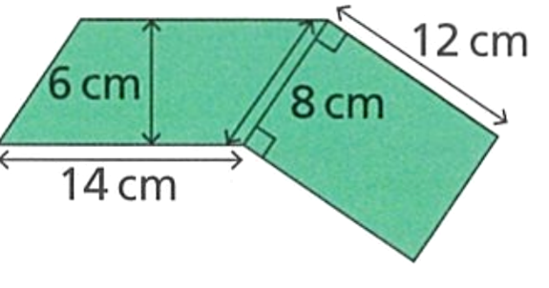  180 cm² | 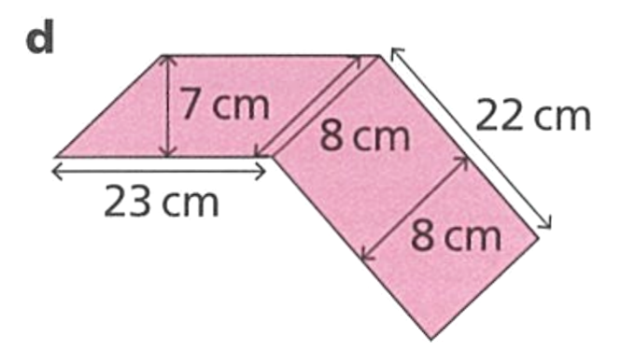  337 cm²
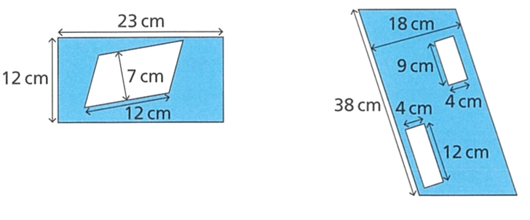  192 cm² | 600 cm²

- A backyard is a rectangle with dimensions 18 m by 12 m.
A triangular swimming pool with a base of 6 m and a perpendicular height of 4 m is constructed in one section, and a square patio with a side length of 5 m is paved in another.
Calculate the remaining area of the yard to the nearest whole.
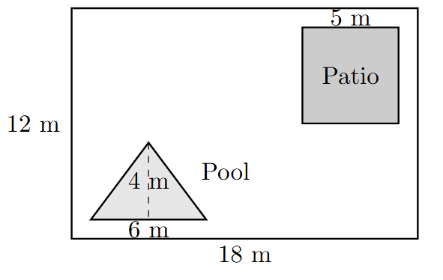

179 m²
- 2009 HSC Standard 2 Band 4
The diagram shows the shape and dimensions of a terrace which is to be tiled.
Find the area of the terrace.
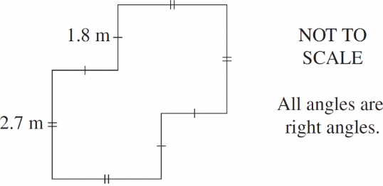

Treat the area as one big square – two small squares
13.77 m²

Mastery
- 2019 HSC Standard 2 Band 5
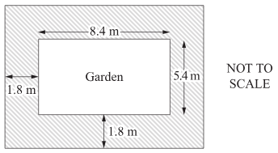
A path 1.8 m wide is being built around a rectangular garden.
The garden is 8.4 m long and 5.4 m wide. The path is shaded in the diagram.
The path is to be covered with triangular pavers with side lengths of 15 cm and 20 cm as shown. How many pavers are needed?
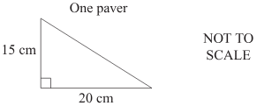

Shaded area is $12×9-8.4×5.4=62.64 m^{2}=626400 {cm}^{2}$
Each paver is $\frac{1}{2}$ $×20×15=150 {cm}^{2}$
$∴$ Number of pavers is 4176
- Nepal is the only country in the world that does not have a rectangular flag.
It is made up of two triangles, with an intersected (shared) area.
Show that the area of the flag is 3.12 m².
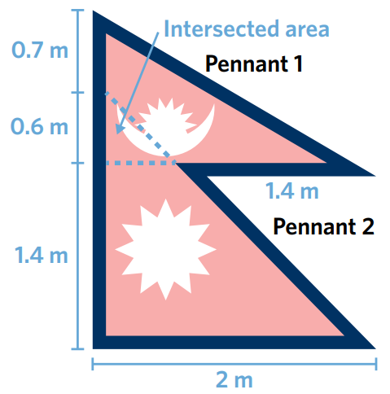

Area of pennant 1: $\frac{1}{2}$ $×\left(0.6+0.7\right)×2$
Area of pennant 2: $\frac{1}{2}$ $×\left(1.4+0.6\right)×2$
Overlapping area: $\frac{1}{2}$ $×\left(0.6×0.6\right)$
Total area is the two pennants subtract the overlapping area = 3.12 m²

Finding Unknown Sides Given the Area

- Area Formulas
Rectangle  $$A=lw$$ | Square  $$A=l^{2}$$ | Parallelogram  $$A=bh$$ | Triangle  $$A=\frac{bh}{2}$$
Steps for using any formula:
1. Write the formula.
2. Substitute given values.
3. Solve for the unknown value using inverse operations.

- Example Calculate the side length given the area
Example | Your Turn
The area of the rectangle is $A=1.53 m^{2}$  Find the value of $x$.  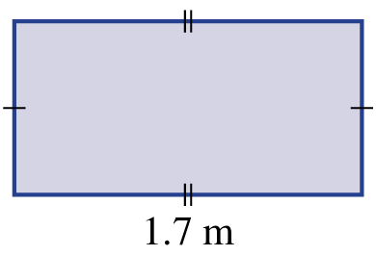  $$x$$  1. Write the formula $A=lw$2. Substitute $1.53=1.7x$3. Solve $÷1.7 ÷1.7$  $0.9 m=x$ | The area of the rectangle is $A=140.8 m^{2}$  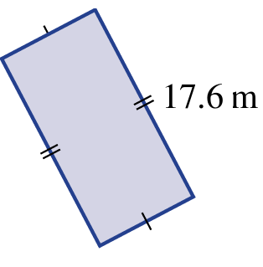  Find the value of $x$.  $$x$$  1.  2.  3.  8 m
The area of the triangle is $A=192 cm^{2}$  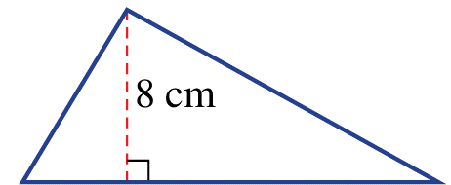  Find the value of $x$.  $$x$$  1. Write the formula $A=$ $\frac{bh}{2}$2. Substitute $192=$ $\frac{8b}{2}$3. Solve $×2 ×2$  $384=8b$  $÷8 ÷8$  $48 cm=b$ | The area of the triangle is $A=69.3 cm^{2}$  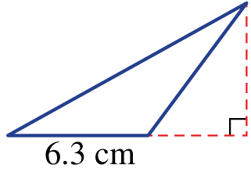  Find the value of $x$.  $$x$$  1.  2.  3.  22 cm

Foundation
- Calculate the missing side length for each of these rectangles, write an equation.
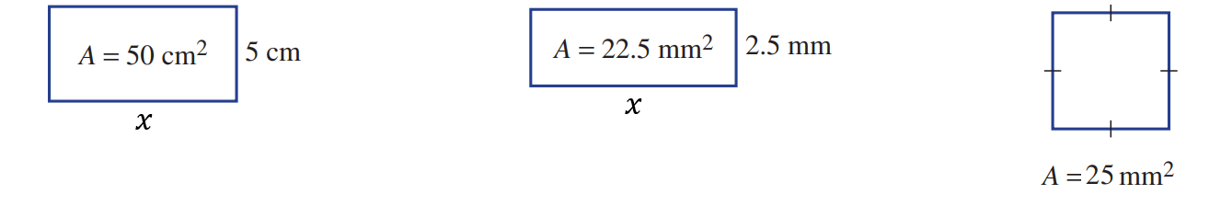  $A=lw$  $50=5x$  $÷5=÷5$  ……… $=x$  10 cm | $$A=lw \\ 22.5=2.5x$$  9 cm | $$A=l^{2}$$  5 cm
- $A=12.8$ cm²  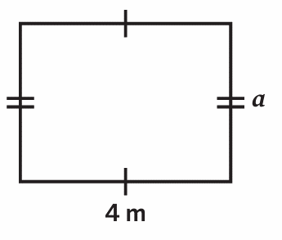  3.2 cm | - $A=1.44$ cm²  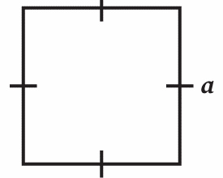  1.2 cm | 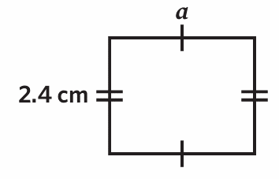  - $A=15$cm²  6.25 cm

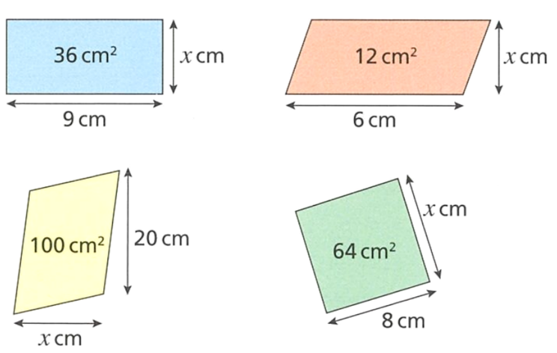
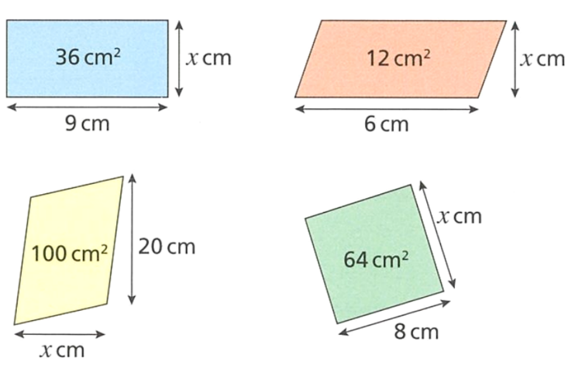
- Find the missing side lengths in these shapes.
4 cm | 2 cm | 5 cm
8 cm | 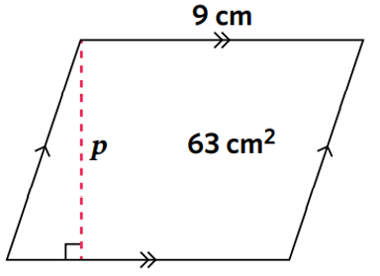  7 cm | 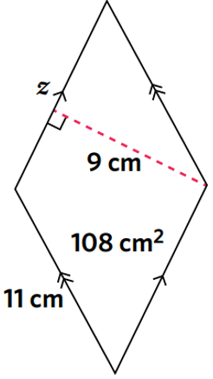  12 cm

Development
- Find the missing value for each pronumeral.
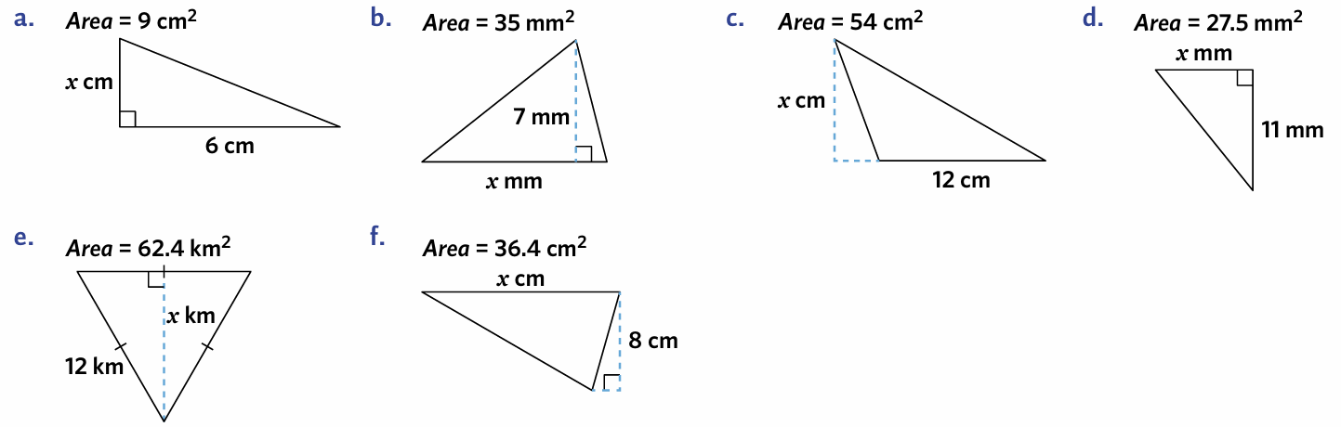  $$A=\frac{bh}{2}$$  $$9=\frac{6x}{2}$$  $$×2=×2 \\ 18=6x$$  $$÷6=÷6$$ ……… $=x$  3 cm | $$A=\frac{bh}{2}$$  $$35=\frac{7x}{2}$$  10 mm | 9 cm
5 mm | 10.4 km | 9.1 cm

- Complete the table.
Shape | Base  (cm) | Perpendicular  Height (cm) | Area  (cm²)
Rectangle | 5 | 7 | 35
Triangle | 5 | 7 | 17.5
Triangle | 9 | 4 | 18
Parallelogram | 5 | 7 | 35
Parallelogram | 9 | 4 | 36
Rectangle | 20 | 5 | 100
Parallelogram | 3 | 12 | 36
Triangle | 12 | 11 | 66
- The area of the parallelogram is twice the area of the rectangle.
Work out the height of the rectangle.
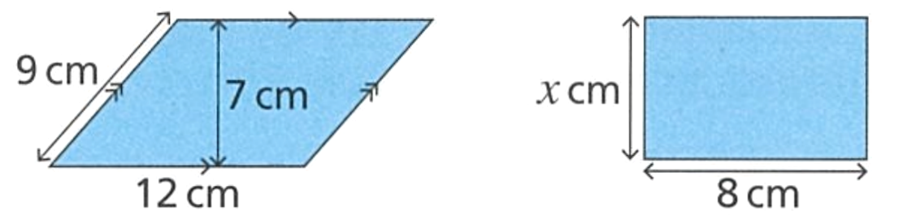

Area of parallelogram: 84 cm
Area of rectangle: 42 cm
$$8x=42$$
$x=$ 5.25 cm

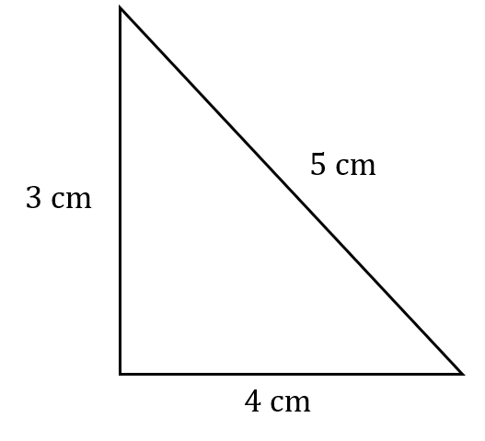  - Find the perimeter.  12 cm | - Find the area.  6 cm²
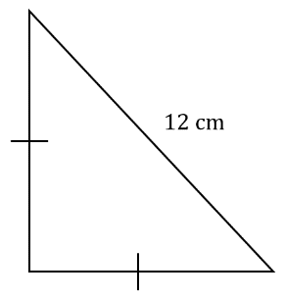  - The perimeter is 29 cm.  Find the side lengths.  8.5 cm | 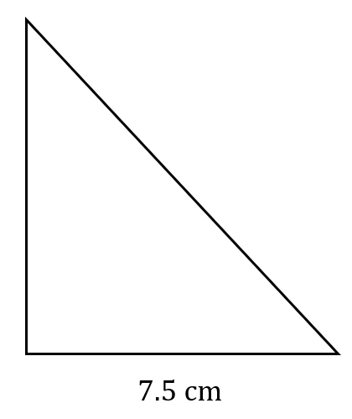  - The area is 15 cm².  The perimeter is 20 cm.  Find the side lengths.  4 cm and 8.5 cm

- Find the missing length.
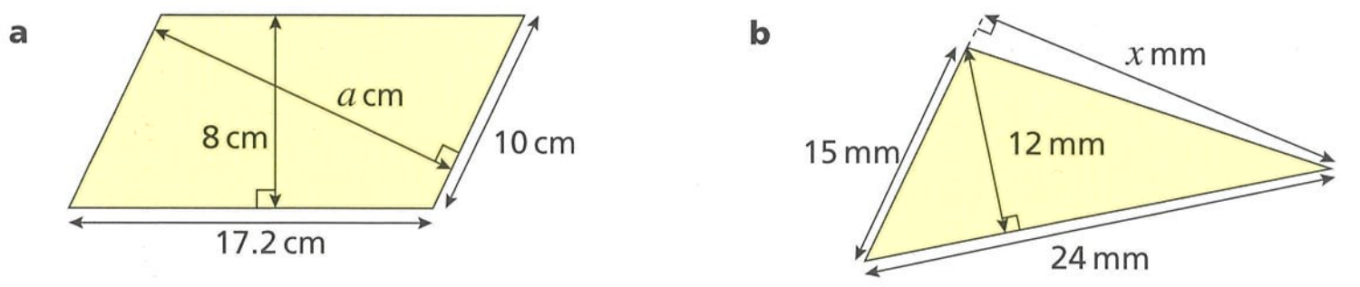  13.76 cm | 19.2 cm

Mastery
- Find the missing side length.
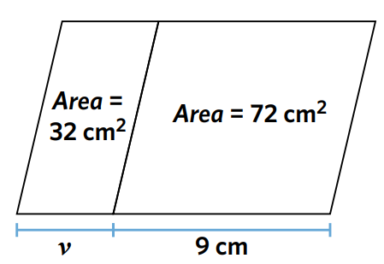

4 cm
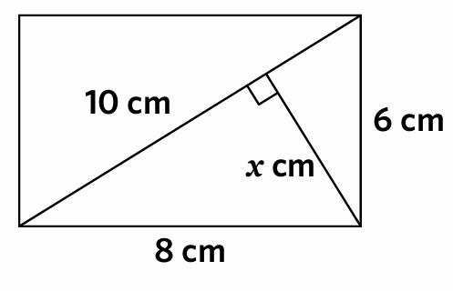
- Find the value of $x$. 10 cm is the length of the entire diagonal.

4.8 cm
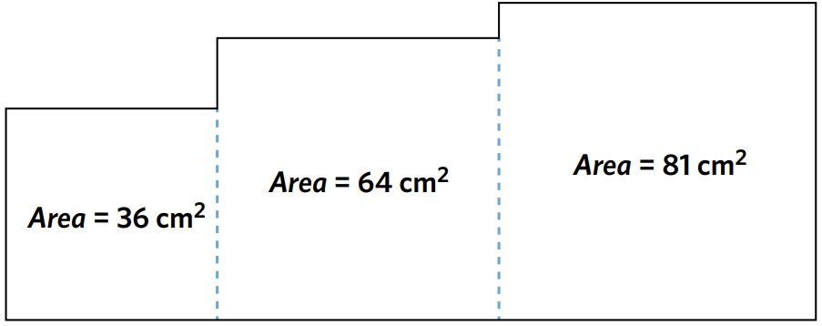
- Three squares are joined together to form a shape. Calculate the perimeter of the entire shape.

64 cm
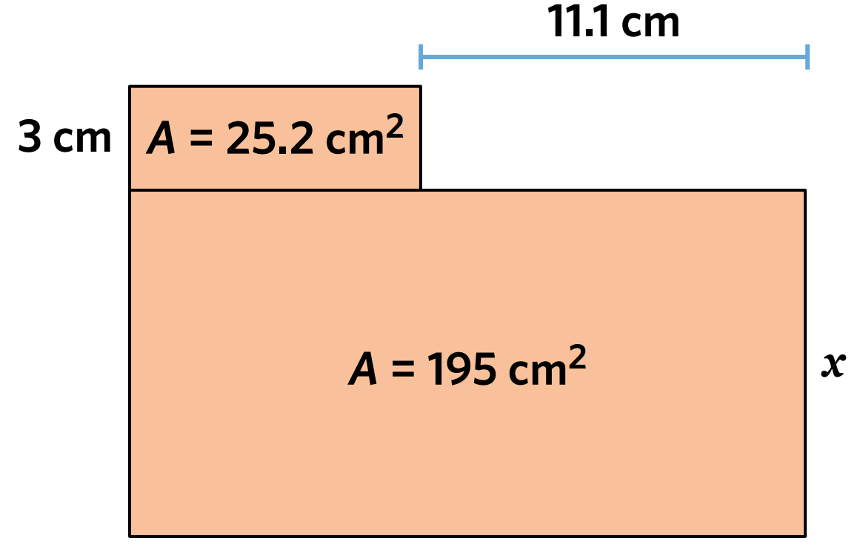
- Solve for the pronumeral $x$.

10 cm
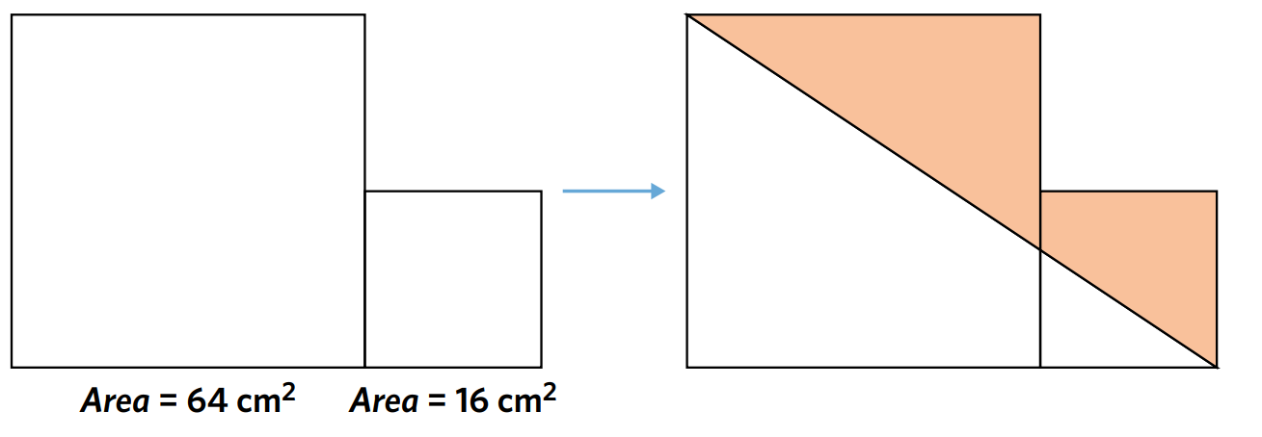
- What is the area of the shaded section?

32 cm²

